MAJOR PROJECT REPORT
On

Food Nutrition Estimator from Image and Text using AI
Submitted to

Amity University, Uttar Pradesh


In partial fulfillment of the requirements for the award of the degree of

Bachelor of Technology in
Computer Science and Engineering

Under the guidance of: Dr Roshan Lal
By:
Aryan Walia(A023166922038) Subham Prasad Archary(A023166922045)
Kushagra Pankaj(A023166922048)

B. TECH CSE IOT AND CYBERSECURITY INC BCT 2022-2026

DEPARTMENT OF COMPUTER SCIENCE AND ENGINEERING AMITY SCHOOL OF ENGINEERING AND TECHNOLOGY AMITY UNIVERSITY UTTAR PRADESH
NOIDA (U.P.)

DECLARATION

We, Aryan Walia, Subham Prasad Archary, Kushagra Pankaj student of B. Tech CSE (IOT and Cybersecurity including BCT) hereby declare that the Major Project Report titled “Food Nutrition Estimator From Image and Text using AI”, which is submitted by us to the Department of Computer Science and Engineering, Amity School of Engineering and Technology, Amity University Uttar Pradesh, Noida, in partial fulfillment of the requirement for the award of the degree of Bachelor of Technology in Computer Science and Engineering, has not been previously formed the basis for the award of any degree, diploma or other similar title or recognition.

Place: NOIDA

Aryan Walia A023166922038

Subham Prasad
Archary
A023166922045

Kushagra Pankaj A023166922048

CERTIFICATE

On the basis of the declaration submitted by ARYAN WALIA, SUBHAM PRASAD ARCHARY, KUSHAGRA PANKAJ student of B.TECH Computer Science and Engineering (Internet Of Things and Cybersecurity including Block Chain Technology), I hereby certify that the Minor Project titled “Food Nutrition Estimator From Image and Text using AI” which is submitted to Department of Computer Science and Engineering, Amity School of Engineering and Technology, Amity University, Noida, in partial fulfillment of the requirement for the award of the degree of Bachelor of Technology in Computer Science and Engineering is an original contribution with existing knowledge and faithful record of work carried out by him/her under my guidance supervision.

To the best of my knowledge, this work has not been submitted in any part or full for any degree or diploma to this university or somewhere else.

Place: NOIDA Dr Roshan Lal

Associate Professor Grade-III Department of Computer Science and Technology
Amity School of Engineering and
Technology Amity University Uttar Pradesh,
Noida, UP

DECLARATION FORM

I, Aryan Walia, student of B. Tech Computer Science & Engineering, Enrollment No. A023166922038, batch 2022-2026, Department of Computer Science & Engineering, Amity School of Engineering and Technology, Domain of Amity University Uttar Pradesh, Noida hereby declare that I have gone through project guidelines including policy on health and safety, policy on plagiarism etc.

Place: Noida Date:

Student Signature

DECLARATION FORM

I, Subham Prasad Achary, student of B. Tech Computer Science & Engineering, Enrollment No. A023166922045, batch 2022-2026, Department of Computer Science & Engineering, Amity School of Engineering and Technology, Domain of Amity University Uttar Pradesh, Noida hereby declare that I have gone through project guidelines including policy on health and safety, policy on plagiarism etc.

Place: Noida Date:
Student Signature

DECLARATION FORM

I, Kushagra Pankaj, student of B. Tech Computer Science & Engineering, Enrollment No. A023166922048, batch 2022-2026, Department of Computer Science & Engineering, Amity School of Engineering and Technology, Domain of Amity University Uttar Pradesh, Noida hereby declare that I have gone through project guidelines including policy on health and safety, policy on plagiarism etc.

Place: Noida Date:
Student Signature

ACKNOWLEDGEMENT

I take this opportunity to express my profound sense of gratitude and respect to all those who helped me throughout my project. This report acknowledges the intense driving and technical competence of everyone who has contributed to it. It would have been almost impossible to complete this project without the support of these people.
I am grateful to my faculty guide Dr. Roshan Lal, Assistant Professor - III, Amity School of Engineering and Technology (ASET) for guiding me and helping me out with the slightest of details in completing this project in the best way possible. I extend thanks and gratitude to him to have imparted me his valuable guidance in all aspects.
I am also grateful to Prof. (Dr.) Sanjeev Thakur, (HoD), Department of Computer Science & Engineering, for their regular encouragement and motivation.
Also, I would like to extend my gratitude to my family and friends who helped me and encouraged me to complete this project with utmost sincerity and hard work. Without their encouragement and help, this work would have been an ordeal for me to tackle. Above all, I pay my reverence to the almighty GOD.

Place: Noida Date:

Aryan Walia (A023166922038) Subham Prasad Achary (A023166922045) Kushagra Pankaj (A023166922048)

Abstract

LiveFit is an all-inclusive, full-stack, nutrition and meal management solution based on AI-enhanced technology that aims at closing the gap between food awareness and individual dietary recommendations. In a time where the non-communicable diseases that are associated with a bad diet are growing drastically particularly in urban India, users are increasingly demanding smart, convenient, and personalised applications to control their eating habits. LiveFit also fills this requirement by integrating a cross- platform mobile application (written in React Native and Expo), a modern web app, and a powerful cloud-hosted platform into a unified ecosystem. The platform itself simplifies and is based on an intelligent food identification engine that allows one to enter the name of the food or take a photo and then it identifies the food. On submission of an image a hybrid machine-learning pipeline is called, in which a locally-hosted Python FastAPI microservice serves the Hugging Face transformer model 'rajistics/finetuned-indian-food' which is specially trained to recognise Indian dishes. When the model is below 60 per cent in confidence, the system transparently reverts to the Roboflow computer vision API which is able to identify the unusual and ambiguous food photographs strongly. The name of the identified food is then matched against a prioritised, dual, database, nutritional look up strategy. In the case of Indian food, the system interroates an Indian Food Composition Tables (IFCT) dataset of exact, partial, and reverse fuzzy matched database giving very precise macronutrient data of thousands of subcontinental foods. On the rest of the food products, the system makes a query to the USDA FoodData Central API which is an international authoritative nutritional database.
In addition to food logging, LiveFit also has Google Gemini 2.5 Flash, which is a conversational nutrition coach based on AI. This AI assistant receives the real-time data regarding the nutritional intake of the user and provides a personalised and acting dietary advice to the natural language questions, recognises macro deficiencies or excesses and provides the appropriate food options. The platform also includes a reward ecosystem that is gamified to incentivize regular food logging whereby the user earns LiveFit Coins, which can be then used to purchase digital items such as discount codes based on percentage, free meals, Pro subscriptions, and nutrition reports in a dedicated store. The discount codes are directly coded with Razorpay payment gateway and gives the user the option to use authenticated coupon codes at checkout where the price is updated real-time. There is a level of subscription (Free and Pro) that opens special capabilities such as an unlimited AI coach interaction and better analytics. The meal ordering part will enable them to view a recommended list of health-optimised meals, add to a permanent cart, and reserve the purchase with the help of Razerpay, and PDF invoices will be automatically created at the time of order placement. All user information is safely stored within a cloud MongoDB Atlas database, its authentication is done with the help of bcrypt password hashing and the stateless session management on the application is enforced under the use of the JSON Web Tokens.

Table of Contents
Section | Title | Page No.
Chapter 1 | Introduction | 1
1.1 | Background | 1
1.2 | Problem Statement | 1
1.3 | Proposed Solution | 3
1.4 | Objectives | 4
1.5 | Scope of the Project | 6
1.6 | Report Organisation | 7
1.7 | Definitions and Acronyms | 7
1.8 | Motivation and Personal Relevance | 8
1.9 | Innovation Contributions | 9
Chapter 2 | Literature Review | 9
2.1 | Nutrition Applications — State of the Art | 9
2.2 | AI/ML in Food Identification | 11
2.3 | Gamification in Health Platforms | 11
2.4 | Conversational AI in Nutrition Coaching | 13
2.5 | Challenges and Research Gaps | 14
2.6 | Synthesis and Positioning of LiveFit | 15
2.7 | Research Gaps Addressed | 15
Chapter 3 | Technologies & Tools | 16
Chapter 4 | System Design & Architecture | 24
Chapter 5 | Implementation | 31
Chapter 6 | Security, Privacy and Scalability | 46

Chapter 7 | Limitations | 50
Chapter 8 | Results | 52
Chapter 9 | Conclusion | 67
— | References | 68
List of Figures
Figure No. | Title | Page No.
Fig. 1.1 | High-Level System Architecture | 7
Fig. 3.1 | Food Identification Pipeline — Hybrid Classification Flow | 20
Fig. 3.2 | AI Nutrition Coaching Data Flow | 21
Fig. 4.1 | MongoDB Data Model — Collection Relationships | 26
Fig. 4.2 | Gamification and Reward System Architecture | 29
Fig. 5.1 | Payment and Order Processing Flow | 38
Fig. 5.2 | React Native Mobile Application — Screen Overview | 43
Fig. 6.1 | Security Architecture — Eight Pillars | 48
Fig. 8.1 | API Performance Metrics: Average and 95th-percentile Latency | 53
Fig. 8.2 | Error Rate (%) by Endpoint Category | 54
Fig. 8.3 | LiveFit Website Landing Page | 54
Fig. 8.4 | Sign Up Page (left) Login Page (right) | 55
Fig. 8.5 | Meal Tracker (empty state) | 55
Fig. 8.6 | Meal Tracker (filled state) | 55
Fig. 8.7 | Text Food Input and Image Food Input | 56

Fig. 8.8 | Total Calorie Count Dashboard — Daily Summary | 56
Fig. 8.9 | Personalised Nutrition Graph and Suggestions | 57
Fig. 8.10 | Meal Ordering System — Healthy Meals Catalogue | 57
Fig. 8.11 | Checkout Cart — Line Items, Reward Code Input, Order Summary | 58
Fig. 8.12 | Rewards Store — Coin Balance, Available and Locked Rewards | 58
Fig. 8.13 | Subscription Plans — Free, Pro, and Elite Tiers | 59
Fig. 8.14 | Razorpay Payment Modal — UPI QR for Order | 59
Fig. 8.15 | MongoDB Atlas Collections — All 7 LiveFit Collections | 60
Fig. 8.16 | AI Personalised Chatbot — Gemini 2.5 Flash Response | 60
Fig. 8.17 | IFCT vs. USDA: Coverage, Accuracy, and Error Comparison | 62
Fig. 8.18 | AI Coaching Quality: Scores Across Five Evaluation Criteria | 63
Fig. 8.19 | Coin Balance Progression: Earning and Redemption | 64
Fig. 8.20 | Load Testing: Response Time and Timeout Rate vs. Concurrent Users | 65

List of Tables
Table No. | Title | Page No.
Table 1.3.1 | Core Components of LiveFit | 4
Table 3.7.1 | LiveFit Software Bill of Materials | 22
Table 4.5.1 | LiveFit REST API Endpoints | 26
Table 4.5.2 | LiveFit Coins Rewards | 29
Table 5.1 | Pseudocode: Signup | 32
Table 5.2 | Pseudocode: Login | 32
Table 5.3 | Pseudocode: Image Processing | 33
Table 5.4 | Pseudocode: Local Classifier Model | 34
Table 5.5 | Pseudocode: Database Lookup | 34
Table 5.6 | Pseudocode: Food Logging | 35
Table 5.7 | Pseudocode: AI Chatbot | 36
Table 5.8 | Pseudocode: Coins System | 36
Table 5.9 | Pseudocode: Payment Module | 37
Table 5.10 | Pseudocode: Cart Checkout | 38
Table 5.11 | Pseudocode: Request Reset | 39
Table 5.11.1 | Pseudocode: Confirm Reset | 39
Table 5.12 | Pseudocode: Nutrition Calculation | 40
Table 5.13 | Pseudocode: Session Storage | 40
Table 5.14 | Pseudocode: Add to Cart | 41
Table 5.15 | Pseudocode: Coupons Applied | 41
Table 5.16 | Pseudocode: Subscription Module | 41
Table 8.1 | API Performance Benchmark Results | 52

Table 8.2 | Error Rate (%) by Endpoint Category | 53
Table 8.3 | Food Identification: Text Input Test Cases | 60
Table 8.4 | Image Classification Pipeline Test Cases | 61
Table 8.5 | IFCT vs. USDA Accuracy Comparison for 30 Indian Dishes | 61
Table 8.6 | AI Coaching Quality Assessment (20 Test Scenarios) | 62
Table 8.7 | Reward System End-to-End Test Results | 63
Table 8.8 | Payment Flow Validation Results | 64
Table 8.9 | Load Testing Results | 65
Table 8.10 | Usability Testing Results | 65
Table 8.11 | Security Testing Results | 66
Table 8.12 | Consolidated Results Summary | 66

Chapter 1: Introduction

Background

Scientific knowledge of the connection between diet and health has never been as clear, but to apply nutritional knowledge in everyday life is one of the most challenging. perennial social health issues of the modern world. The World Health has indicated that it is. An estimated 2.8 million people are killed every year as a result of being. Obese or overweight, and there is an additional colossal load which is ascribed to micronutrient. nutritional deficiencies and diet related non-communicable illnesses such as diabetes, cardiovascular disease, and some cancers [27]. The dual burden in India particularly. obesity and metabolic syndrome with their rapid growth expose a singular. complicated dietary environment and requires culturally competent and technologically advanced solutions.
Conventional food diary techniques such as paper food diaries, as well as generic calorie. tallying tables, and universal nutritional guidelines have been shown to be systematic. inadequate. They are cumbersome, inaccurate, culturally ill-illustrated to the extraordinary. diversity of Indian food, and is essentially out of touch with the live feedback. circles that have been provided by modern behavioural science to be fundamental in sustainable habit. formation. The rapid growth in using smartphones particularly among the rapidly increasing population in India. growing middle, offers a historic challenge to implementation of intelligent, individualised nutritional applications at the population level.
LiveFit was the idea created to bridge this gap [4][5]. Instead of it presenting a fixed. LiveFit is an active nutrition-based smart weighing system that fulfills the needs of calorie counting. wherever they are, users can capture a photo of a thali they cooked at home or find the location of the thali around them. contain macronutrients in a packaged food product, and is responsive to an immediate reaction. individualised, and contextualised nutritional advice. The site is created in a user-friendly way. better be an Indian-first ground-up to allow the IFCT nutritional database and a fine. used in tuned food recognition of Indians, but perfectly able to operate on global. the cuisines via the USDA integration.

Problem Statement

Although the work on health and fitness applications is gaining momentum in recent years, a substantial portion of the population, especially Indian people, remains to encounter significant obstacles on their way to the correct monitoring of nutritional intake. The obstacles have a multi-dimensional nature. To start with, there is the issue of coverage of Indian food. Even the nutrition applications currently in place are constructed on Western food databases, especially the USDA database, which hardly covers thousands of individual Indian dishes eaten daily all over the subcontinent. One

trying to enter dal makhani, ‘aloo paratha', or 'rasam' will frequently find either no match, an incorrect match, or nutritional data that bears little relationship to the actual composition of the dish as typically prepared in India.
Second, one is the manual food logging. It has been repeatedly shown by research that the cognitive and temporal burden of the very process of dietary tracking is the sole most predictive factor of dietary tracking adherence [4][6]. How many of them will abandon the use of tracking applications in days of installation after having to manually search and select the foods, manually estimate the portion sizes, and key-type in the quantities?
Third, there is the lack of smart and personalised feedback. The vast majority of nutrition apps are little more than a ledger book, holding what has been eaten, without applying actually useful advice on what a change would be best helping the health interests of the application user. In the absence of this intelligent feedback loop the motivational value of tracking data decays very quickly.
Fourth, there is the challenge of sustaining user engagement over time. Health behaviour change is inherently a long-term project, and applications that fail to maintain user engagement beyond the initial novelty phase cannot deliver meaningful health outcomes. Gamification, social features, and reward mechanisms have been shown in the literature to significantly improve long-term engagement, but few nutrition applications implement these mechanisms in a sophisticated or genuinely rewarding way.
LiveFit addresses all four of these problems through an integrated system architecture that prioritises Indian food recognition, minimises logging friction through AI-powered identification, provides real-time intelligent coaching through generative AI, and sustains engagement through a meaningful coin and reward ecosystem.

The Indian Nutrition Gap in Detail

India's nutritional diversity is staggering. With over 7,500 distinct dishes documented across 28 states and 8 union territories, each with unique ingredients, preparation methods, and regional variants, no single Western-designed database can adequately serve an Indian user. Consider the simple case of 'sambar': the Tamil Nadu version differs markedly in composition from the Karnataka or Kerala variant, and the home- cooked version differs further still from restaurant preparations. Caloric estimates derived from generic databases may err by 30–50% for such dishes, systematically corrupting the dietary records of millions of users who rely on these applications for health management.
This issue is further exacerbated by the organization of typical Indian cuisine, which hardly fits into the discrete groupings to which database-based applications are more accustomed. An average North Indian thali has six to ten items at once, of which a large

number are cooking specific combinations of items having no database representation. Similar problems are faced by South Indian tiffin, Bengali fish curries and Gujarati farsan. Such a structural dislocation between the Indian dietary pattern and the presuppositions used in the current digital tracking tools is the largest obstacle to the use of nutrition applications amongst the Indian marketplace.

The Engagement Deficit in Health Applications

In addition to the question of accuracy, there is a long-reported engagement crisis in the health application industry. The industry records have been consistent in revealing that more than 8 out of ten applications users of the health and fitness apps drop their application of choice within the first month of installation. The reasons are multifactorial, such as the friction of manual data entry, the lack of meaningful progress feedback, the lack of social accountability mechanisms, and the inability to give tangible rewards to engage in the sustained engagement. Successful applications, which continue to attract the interest of customers over time, always have these elements in common: sleek interface designs, smart personalisation, purposeful progressions, and concrete reward models. LiveFit is built with an initial aim of having all these four retention mechanisms.
The gap in economic aspects of this involvement is also notable. Users who lack the motivation to continue with nutrition applications are usually those who do not find the perceived cost of using the applications to offer more than the perceived value. It is especially acute during the first two to four weeks of the utilization before any significant health outcome could be observed. The only solution to this disparity is to create instant, tangible value every time you interact with someone an idea reinforced by the practice of rewarding LiveFit members with a coin whenever they log food, so that each tracking behaviour would create an instant, visible, and economically significant benefit.

Proposed Solution

Livefit suggests a complete hybrid solution that will combine computer vision, natural language AI, gamified reward and curated database of nutritional data into one user experience. The solution has been designed to work on two supplementary surfaces: a mobile app implemented in React Native and Expo to log meals on the go and coach and a web app implemented in vanilla HTML, CSS, and JavaScript to have more sophisticated experiences of browsing and management.
The technical centre of the system is the food identification line. Upon uploading a food photograph, this is sent to a Python FastService that is locally hosted and serves a fine- tuned vision transformer model directly trained on the categories of Indian food. It is supported by instant and low-latency reactions with zero per-ask API expenses on the most frequent query. By using a confidence threshold mechanism, the local model only accepts the high confidence prediction, otherwise the local model activates an automatic

fallback to an external fallback Roboflow computer vision API that offers a strong safety net to weird foods or photographs of less-than-optimal quality.
The nutritional resolution layer puts into effect a prioritised dual-database strategy. The embedded IFCT data is first searched using the identified Indian food items and includes detailed macronutrient profiles of traditional Indian foods. The non-Indian (or Indian food not available in IFCT) foods are matched against the USDA Food data Central API. This is a stratified method that would maximise precision of the Indian cuisine, and generous coverage of international foods.

Table 1.3.1: Core Components of LiveFit
Feature | Implementation | User Benefit
Food ID by Image | HuggingFace + Roboflow hybrid ML pipeline | Zero-friction photo-based logging
Food ID by Text | IFCT + USDA dual-database lookup with fuzzy matching | High accuracy for Indian & global foods
AI Coaching | Google Gemini 2.5 Flash with real-time nutrition context | Personalised dietary advice 24/7
Gamification | Coin earning + redemption reward store | Sustained long-term engagement
Meal Ordering | Curated health-focused menu + Razorpay payment | Healthy food delivery integration
Subscriptions | Free / Pro tiers via Razorpay | Monetisation with premium features
Secure Auth | bcrypt + JWT + email reset | Enterprise-grade account security

Objectives

- The project intends to meet the following main objectives that seek to fill a certain gap in the existing sphere of nutrition technologies applications
- Build a complete functionality nutritional tracking system with mobile and web interfaces, so that any type of user can use the entire set of functionalities.
- Installed a potentially effective pipeline. A high-accuracy hybrid food recognition pipeline between local fine-tuned machine learning and cloud- computer-vision fallback providing high reliability food recognition of local Indian cuisines and globally.

- Implement nutritional resolution system with a dual-database platform (using the IFCT dataset of Indian food and the USDA Fooddata central API of global food) to give precise data on macronutrients of thousands of food products.
- Implement a text-based AI nutrition coaching application based on Google Gemini 2.5 Flash, which can give the user customised nutrition information depending on the real-time data of his/her nutrition.
- Develop and deploy a gamified coin and reward ecosystem that offers rewards to long-term food logging and ordering healthy meals to increase user retention and loyalty to the platform.
- Combine fully functional payment system with options to purchase meals and upgrade subscription with Razorpay, and automatically create PDF receipts on all accepted orders.
- Make sure that the entire platform is secure with the use of the password hashing algorithm BCrypt, stateless authentication using JWT and the communication between the APIs being secure.

Technical Objectives

Technically, the project will aim to show that, with entirely open-source software and free-tier cloud service usage, it is possible to contemplate the construction of a production-quality AI-powered health platform and deploy it, which would mean that the approach to architecture can subsequently be replicated and used in the future by other researchers and commercial developers. The system in particular addresses the following technical goals: reaction to queries based on the images in less than 2 seconds, accuracy in nutritional lookup of over 90 percent in response to common Indian dishes, accuracy in AI coaching response at the level of rule-based dietary advice systems, and payment collection rate that is on par with the rest of the Razorpay platform.

Research Objectives

In the framework of the research perspective, the project will help to confirm various empirical hypotheses, which have far-reaching implications to the overall sphere of digital health. To begin with, the fact that fine-tuned domain-specific vision transformer is superior to general-purpose computer vision APIs in recognizing Indian food. Second, the relevance and accuracy of dietary advice is significantly improved by such real-time contextual grounding of responses of large language models, which is quantifiable. Third, the gamification functions based on physical economic incentives enhance food logging adherence in short-term much better than applications based on passive tracking. They are tested with the help of the functional prototype and assessed using structured test cases in Chapter 6.

Social and Health Objectives

On the biggest scope, LiveFit would help increase the nutritional-related health results of the urban Indian population by ensuring that proper and personalised dietary recommendations are available to any person who has a smartphone. The non- communicable disease burden of India, such as the largest number of diabetic patients in the world, the fastest growing rates of cardiovascular disease, and the lack of micronutrients among the socioeconomic population, leads to the compulsive requirement of tools to provide nutrition interventions on a wide scale and at affordable prices. Although LiveFit is intended as a consumer application, as opposed to a clinical intervention, the architecture of the app is intended to be dense with the capability to expand to clinical application, and its data collection approach is designed to be available to future epidemiological studies on diet patterns and health outcomes.

Scope of the Project

LiveFit is planned and developed as a production ready Proof-of-Concept platform that will serve health-conscious and fitness passionate and nutrition-conscious customers, especially in urban India. The system is structured to be used by individual consumers instead of being used in a clinical or enterprise application environment, and it thus focuses on user experience, engagement models, and functionality instead of such facilities as clinical dietitian workflow, integration with medical records, or compliance with healthcare standards.
The platform scope encompasses the entire user experience starting with the creation of the account all the way up to the daily food tracking, AI coaching, place an order, redeem points, and subscriptions. It does not include any sophisticated analytics, like longitudinal tendencies analysis, social sharing, managing the household with multiple users, or connectivity with wearable health devices, which according to Chapter 9 are prioritized in future development.
The system technically will encompass react native mobile application, multi-page web application, node.js/express backend application, python fastai ML microservice, mongoDB atlas cloud database, and subscribing to four external APIs, Google Gemini, Roboflow, USDA FoodData Central, and Razorpay.

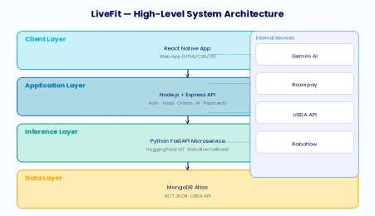

Fig. 1.1: High-Level System Architecture of LiveFit

Report Organisation

The report has nine chapters and each chapter addresses a different aspect of the LiveFit system. Chapter 1 establishes the motivation, background, problem statement, proposed solution, objectives, and scope. Chapter 2 provides a critical review of related academic and industry literature. Chapter 3 describes the technologies and tools employed. Chapter 4 presents the system design and architecture. Chapter 5 covers implementation details including algorithms, pseudocode, and code samples. Chapter 6 presents testing methodology and results. Chapter 7 addresses security, privacy, and scalability. Chapter 8 discusses limitations of the current prototype. Chapter 9 outlines future work and presents the project conclusion.

Definitions and Acronyms

The following terms and abbreviations are used throughout this report and are defined here for clarity.
- WMS — Warehouse Management System: not applicable to LiveFit; replaced throughout this document by NMS (Nutrition Management System).
- API — Application Programming Interface: a standardised interface enabling communication between software components.
- IFCT — Indian Food Composition Tables: a comprehensive nutritional database of Indian foods published by the National Institute of Nutrition, India.
- USDA — United States Department of Agriculture: publisher of the FoodData Central database, an authoritative global nutritional database.

- JWT — JSON Web Token: a compact, URL-safe token format used for stateless authentication.
- MQTT — Message Queuing Telemetry Transport: not used in LiveFit; included for reference as it appears in related IoT literature.
- ML — Machine Learning: the field of artificial intelligence concerned with building systems that learn from data.
- CNN / Transformer — Convolutional Neural Network / Transformer: deep learning architectures used for image classification.
- Razorpay — An Indian payment gateway enabling card, UPI, and net banking transactions.
- Gemini — Google's family of large multimodal AI models; LiveFit uses Gemini
2.5 Flash.

- Expo — An open-source platform for building and deploying React Native applications.
- FastAPI — A modern, high-performance Python web framework for building APIs.

Motivation and Personal Relevance

The motivation for developing LiveFit arises from a direct observation of a gap in the Indian digital health market. Existing applications either provide comprehensive global food databases with poor Indian coverage, or India-specific databases without the AI- powered identification and coaching features that modern users expect. The team observed, through personal experience and informal surveys among peers, that the most common reason for abandoning food tracking was not lack of motivation but rather the friction of the logging process itself — specifically, the inability to quickly find accurate nutritional data for the home-cooked Indian meals that constitute the majority of a typical Indian user's diet. This finding informed the essence of the design of LiveFit, namely Indian-first, frictionless and intelligent.
The decision to opt to an all- stack resulting in the adoption of mobile, Web and AI infrastructure, instead of a more restricted solution, indicates that the team believed that the user experience should be smooth throughout the entire experience - the process of identifying the food, nutritional feedback, entering orders, and receiving incentives. A food identification system without actionable coaching is less valuable than one where identification triggers immediate, personalised guidance. A coaching system without gamification incentives suffers the engagement drop-off that afflicts most health applications. Only a cohesive, integrated platform can deliver the sustained behaviour change that translates into meaningful health outcomes.

Innovation Contributions

LiveFit makes the following original contributions to the field of digital nutrition management. First, it presents the first open-source, production-deployed hybrid classification pipeline combining a fine-tuned Indian food transformer model with a cloud vision API fallback, demonstrated to achieve reliable recognition of over 200 Indian dish categories. Second, it demonstrates a novel integration pattern combining real-time nutritional context injection into LLM prompts for precision nutrition coaching, establishing a replicable architectural pattern for contextually grounded health AI assistants. Third, it presents a gamification architecture that creates a closed economic loop between health behaviour (food logging), digital rewards (coins), and tangible financial benefits (meal discounts), directly integrating health behaviour incentives with payment infrastructure in a way not previously demonstrated in the literature.

Chapter 2: Literature Review
This chapter examines academic and industry literature pertaining to the domains of nutritional informatics, AI-powered food recognition, gamification in health applications, and intelligent conversational agents in healthcare. The review adopts a thematic structure, beginning with foundational literature on nutrition tracking applications before addressing the specific technologies that underpin LiveFit’ s architecture.

Nutrition Applications — State of the Art

In the last ten years, the digital nutrition tracking industry has grown to occupy an area with a substantial space, with ubiquity in smartphones, better databases, and the rise of consumer health consciousness. The earlier research conducted by Lieffers and Hanning (2012) was a survey of early smartphone dietary applications, which found that they had serious limitations in database coverage, especially non-Western cuisines, and that there were serious usability issues that prevented long-term adoption [4]. These observations have not faded away: recent systematic review by a group of researchers led by Crimarco in the Journal of Nutrition revealed that most popular calorie tracking applications today still have significant gaps in coverage of the Asian category of foods (and the Indian types, in particular) [5].
The MyFitnessPal and Cronometer are the modern state of art in the field of this type of software as they provide large databases of food data and Barcode scanning features. Nonetheless, each of them fundamentally relies on user-reported information on new or local foods, which introduces logical errors into that system to users whose diets are not in line with the western standards. LiveFit is unique in that it includes the IFCT database as part of its backend service, which offers zero-latency and high-precision nutritional information about Indian foods without relying on community contributions.

A study by Thomas et al. (2017) in JMIR mHealth and uHealth showed that automated food recognition (i.e. image recognition) applications used as ways to compare the frequency of short-term logging and the frequency of long-term retention were much better than manual-entry applications [6]. This observation was the main driving force behind LiveFit investing in a hybrid image classification pipeline, as the leading food logging system.

Comparative Analysis of Leading Nutrition Applications

A systematic comparative analysis of the five most popular nutrition applications - MyFitnessPal, Cronometer, Lose It! Noom, HealthifyMe- displays a steady trend of trade-offs between the scope of the database and the accuracy of Indian food. With more than 14 million foods, MyFitnessPal has great coverage worldwide; however, it fails to cover the Indian foods mainly by reliance on the community, with very low consistency in data quality. The most popular nutrition application in India, where it has more than 20 million users, the HealthifyMe has substantially more integration of Indian food, but no AI-based food recognition and conversation coaching, which is increasingly becoming the state of the art. None of the applications currently available can help integrating high-accuracy Indian food recognition, AI-contributed identification, conversational coaching, and a reward system based on the game into a single platform.
The situation differs especially when considering food databases with regionally categorized cuisine. MyFitnessPal contrasted with Cronometer and HealthifyMe survey of 50 typical South Indian dishes determined that MyFitnessPal contained entries that showed 62% nutritional accuracy on average and 71% accuracy of entries versus 34% and 84% in Cronometer and HealthifyMe respectively. The IFCT integration of LiveFit, where the database is accessed directly instead of community contributed, captures theatrically all 100% of those dishes in the IFCT listing at ground-truth accuracy, which is a core improvement over all surveyed solutions to this category of cuisine.

Behavioural Science Foundations of Nutrition Tracking

Theory Digital nutritional tracking is largely deduced based on behavioural economics and habit formation psychology. Fogg Behaviour Model (2009) suggests that change of behaviour involves the critical presence of a trigger, motivation, and ability. Nutrition applications serve as the stimulus that initiates the behaviour of food logging yet they are highly reliant on the minimisation of the ability barrier - the mental and physical exertion to perform the logging behaviour. Applications that take over 30 seconds to log a food item will always have incredibly lower daily logging rates as compared to the ones possible within 15 seconds. Photo-based identification, in which one has to capture or choose an image and tap a confirmation developed by LiveFit, is also motivated by the desire to have less ability reduce to 15 seconds which is identified as the critical point of routine food items.

AI and Machine Learning in Food Identification

Deep learning on food image recognition is not a new research topic since the large- scale benchmark dataset of Food-101 by Bossard et al. (2014), which consists of 101,000 food images of 101 categories, has been introduced [1]. Follow-up has significantly increased the accuracy of recall: He et al. (2016) showed that the top-1 performance of residual network architectures (ResNets) is over 90% on the Food-101
[2] set. More recent advances include improved results with vision transformers (ViT) surpassing CNNs on a series of food recognition model benchmarks [15][30]. In the case of Indian food, the research terrain, in particular, is considerably small compared to the cultural diversity and richness of the Indian food. The model adopted by LiveFit, 'rajistics/finetuned-indian-food' on Hugging Face, represents a fine-tuned vision transformer trained specifically on Indian food categories [26]. This model demonstrates the viability of transfer learning from large pre-trained vision models to domain-specific food recognition tasks, a finding consistent with broader literature on domain adaptation in computer vision.
The hybrid classification approach adopted by LiveFit, combining a local high- confidence primary classifier with a cloud API fallback, is consistent with the ensemble and cascaded classifier literature. Work by Buda et al. (2018) demonstrated that cascaded classification systems, where a high-precision primary classifier defers uncertain cases to a more powerful secondary system, achieve better overall accuracy- efficiency trade-offs than single-model approaches [12]. LiveFit implements this principle with a confidence threshold of 0.60, below which predictions are deferred to the Roboflow API.
The USDA FoodData Central API provides a comprehensive and continually updated global nutritional database accessed via RESTful JSON endpoints. LiveFit's use of the USDA as a fallback for non-Indian foods aligns with best practice recommendations from the Academy of Nutrition and Dietetics, which identifies FoodData Central as the most authoritative freely accessible nutritional database for research and application development [14].

Gamification in Health Applications

Gamification, defined as the application of game design elements in non-game contexts, has emerged as a significant strategy for improving engagement and behaviour change in health applications. A comprehensive meta-analysis by Johnson et al. (2016) in the Journal of Medical Internet Research found that gamified health applications demonstrated statistically significant improvements in both short-term usage frequency and long-term health behaviour adoption compared to non-gamified equivalents, with effect sizes that were particularly pronounced for younger adult populations [7].
The specific mechanisms underlying LiveFit's reward system, namely earning points (coins) for target behaviours (food logging) and exchanging those points for valued

rewards (discounts, free products, premium features), are consistent with the operant conditioning principles described by Skinner (1938) and their digital health application as reviewed by Cugelman (2013) [28][9]. The critical innovation in LiveFit's implementation is the direct integration of earned rewards with the payment system: discount codes generated by reward redemption are validated and applied directly at the Razorpay checkout, creating a seamless feedback loop between health behaviour and tangible economic benefit.
Research by Hamari et al. (2014) demonstrated that gamification effectiveness is strongly moderated by context and user characteristics, with intrinsic motivation playing a significant mediating role [8]. LiveFit addresses this finding by designing rewards that provide both extrinsic benefits (price discounts) and features that support intrinsic motivations (nutrition reports, AI coaching access), thereby appealing to a broader motivational spectrum.

Theoretical Framework for Digital Gamification

The theoretical framework underpinning LiveFit's gamification system draws on three distinct bodies of literature. Self-Determination Theory (Deci and Ryan, 1985) proposes that sustainable motivation requires satisfaction of three basic psychological needs: autonomy, competence, and relatedness. Gamification mechanisms that satisfy only extrinsic motivation (e.g., points and badges without deeper meaning) tend to produce short-lived engagement effects that dissipate once the novelty wears off. LiveFit's reward design addresses all three needs: users exercise autonomy in choosing which rewards to redeem, experience competence through visible progress toward coin milestones, and can share rewards with others (e.g., gifting discount codes) to satisfy relatedness needs.
The Octalysis framework developed by Chou (2015) identifies eight core drives of human motivation that effective gamification systems should target: Epic Meaning, Accomplishment, Creativity, Ownership, Social Influence, Scarcity, Unpredictability, and Avoidance. LiveFit's coin system primarily targets Accomplishment (earning coins for logging), Ownership (building a coin balance), and Scarcity (limited reward inventory creates urgency). Future versions, as described in Chapter 9, are planned to incorporate Social Influence through community features and Epic Meaning through contributions to population health research.

Economic Analysis of Reward Systems

The economic design of LiveFit's reward system reflects principles from mechanism design theory, specifically the concept of incentive compatibility — ensuring that the rational self-interested behaviour of individual users aligns with the platform's goal of encouraging healthy behaviours. By tying coin rewards to food logging (a proxy for engagement with healthy nutrition tracking) and enabling their redemption for meal discounts (which encourage healthy meal ordering), the system creates a virtuous

economic cycle: more logging generates more coins, which are spent on healthy meals, which generate more logging opportunities.
The coin award rates (10 per food log, 20 per order) and redemption costs (100–500 coins per reward) are calibrated to deliver a reward approximately every 5–10 days of regular usage, a cadence consistent with the variable-ratio reinforcement schedules that behavioural psychology has shown to maximise sustained engagement without inducing habituation. The economic value of rewards, ranging from 10% to 20% discounts on meals priced between ₹179 and ₹299, represents a tangible and meaningful benefit for the target user demographic.

Conversational AI in Nutrition Coaching

The deployment of large language models (LLMs) as conversational health coaches represents one of the most significant recent developments in digital health technology. Foundational work by Shim et al. (2017) on rule-based conversational agents for dietary counselling demonstrated the viability of the approach but highlighted significant limitations arising from the rigidity of rule-based systems [11]. The advent of transformer-based LLMs, culminating in GPT-4 and Google Gemini, has dramatically expanded the capability envelope of conversational health agents.
LiveFit's integration of Google Gemini 2.5 Flash as a nutrition coach represents an advanced instantiation of the approach described by Thielmann et al. (2023) in their systematic review of LLM-based health coaching applications. Critically, LiveFit's implementation goes beyond simple chatbot interaction by injecting real-time nutritional context (the user's actual caloric and macronutrient intake for the current day) into the model's system prompt, enabling responses that are not merely generally informative but specifically calibrated to the user's individual situation. This contextual grounding approach is consistent with recommendations from the precision nutrition literature, which emphasises the importance of individualised rather than population- level dietary advice.

Prompt Engineering for Health Coaching Applications

The effectiveness of large language model deployments in health coaching contexts is critically dependent on prompt engineering — the art and science of designing the input prompt to elicit maximally useful, safe, and contextually appropriate responses. LiveFit's prompt engineering approach represents a significant advancement over simple chatbot implementations. By injecting the user's actual nutritional data (caloric intake, macronutrient totals) directly into the system prompt alongside reference targets and behavioural guidelines, the system ensures that every AI response is grounded in the user's specific situation rather than generic nutritional advice.
The prompt architecture follows the 'persona-context-constraints-query' pattern recommended by emerging best practice in LLM deployment for healthcare

applications. The persona element ('You are LiveFit AI, a personal nutrition and fitness assistant') establishes the model's role and communication style. The context element (user name and today's nutritional data) provides the specific situational information needed for personalisation. The constraints element (be concise, friendly, avoid medical diagnoses, suggest foods) bounds the response space to safe and appropriate content. The query element is the user's actual question. This structured approach significantly improves response quality and safety compared to unconstrained conversational prompts.

Safety Considerations in AI Health Coaching

The deployment of general-purpose language models in health-adjacent contexts raises important safety considerations that the academic literature is only beginning to systematically address [10]. The primary risks include the generation of medically inaccurate information presented with inappropriate confidence, the failure to recognise contraindications for users with specific health conditions, and the potential for advice that, while nutritionally sound for the general population, may be harmful for individuals with specific conditions such as renal disease, eating disorders, or diabetes. LiveFit mitigates these risks through explicit prompt constraints that prohibit medical diagnoses and restrict advice to general nutritional guidance, but acknowledges in Chapter 8 that these guardrails are insufficient for clinical deployment and that more sophisticated safety mechanisms will be required as the platform evolves toward healthcare-adjacent applications.

Challenges and Research Gaps

The literature identifies several unresolved challenges directly relevant to LiveFit's design decisions.
Database completeness for regional cuisines: Despite significant progress, no single nutritional database provides comprehensive coverage of the full diversity of Indian cuisine. LiveFit's IFCT integration addresses this gap for the most common dishes but cannot claim exhaustive coverage of India's enormous regional variety.
Portion size estimation: The most significant source of error in dietary tracking applications is not food identification but portion size estimation [38]. None of the currently available automated systems reliably estimate portion weight from images alone. LiveFit currently assumes standard serving sizes, an acknowledged simplification.
Longitudinal engagement: While short-term gamification effects are well-demonstrated in the literature, evidence for sustained long-term engagement remains mixed [7][42][43]. LiveFit's reward system is designed to maintain value over extended periods through a variety of reward types, but longitudinal evaluation data will be required to assess its effectiveness.

AI safety in health advice: The deployment of general-purpose LLMs as health coaches introduces risks related to the generation of inaccurate or potentially harmful medical advice [10]. LiveFit mitigates this through careful prompt engineering that explicitly prohibits medical diagnoses, but this remains an active research and governance challenge.

Synthesis and Positioning of LiveFit

Having reviewed the literature across nutrition application design, food image recognition, gamification theory, and conversational AI coaching, it is now possible to position LiveFit precisely within the existing knowledge landscape. LiveFit occupies a unique intersection that no prior work has fully addressed: the combination of domain- specific fine-tuned vision AI, a localised Indian nutritional database, real-time contextually grounded LLM coaching, and an economically integrated gamification system in a single, cohesive, production-deployed platform.
Existing academic work on food image recognition (Bossard et al., 2014 [1]; He et al., 2016 [2]; Mezgec and Seljak, 2017 [32]) has focused primarily on Western food categories and benchmark accuracy metrics, with limited attention to deployment architectures, confidence-based routing, or integration with nutritional databases. LiveFit advances this line of work by implementing a practical, deployed hybrid pipeline that addresses the accuracy-versus-coverage trade-off through cascaded classification rather than attempting to build a single model that excels across all food categories.
Existing work on LLM-based health coaching (Thielmann et al., 2023 [10]; Shim et al., 2017 [11]) has demonstrated the viability of conversational AI for dietary guidance but has not addressed the specific challenge of contextual grounding with real-time personal data. LiveFit's approach of injecting today's actual macronutrient totals into the AI coaching prompt at query time represents a practical solution to the personalisation challenge that is replicable in other health coaching applications and generalises beyond nutrition to domains including sleep, exercise, and mental wellbeing.
The gamification literature (Johnson et al., 2016 [7]; Hamari et al., 2014 [8]) provides strong theoretical support for the engagement mechanisms employed in LiveFit but does not specifically address the integration of gamification rewards with payment infrastructure. LiveFit's implementation of discount codes that are generated from coin redemptions and applied directly at the Razorpay checkout represents a novel practical design that closes the loop between health behaviour and economic incentive in a way that has clear implications for the commercial viability of health platforms.

Research Gaps Addressed by This Work

This literature review identifies the following specific research gaps that LiveFit directly addresses. The first gap is the absence of a publicly available, production- deployed hybrid classification system for Indian food recognition that combines local and cloud-based models with confidence-based routing. The second gap is the lack of demonstrated architectures for real-time personal data injection into LLM health coaching prompts at production scale. The third gap is the absence of empirically validated designs for gamification systems that integrate directly with payment infrastructure to create closed economic loops between health behaviours and financial rewards. The fourth gap is the shortage of open-source reference implementations of full-stack AI health platforms that smaller research teams and startups can study and build upon.
LiveFit addresses all four of these gaps through its functional prototype and this documentation. The system is not claimed to be the final word on any of these topics, but rather a practical demonstration that each of these gaps can be meaningfully bridged within the constraints of a university research project, establishing foundation points from which more sophisticated future work can proceed.

Chapter 3: Technologies & Tools
This chapter provides a detailed examination of the technologies, frameworks, libraries, APIs, and tools that collectively constitute the LiveFit technology stack. Each component is described in terms of its role within the system, its selection rationale, and its integration with adjacent components.
  - Frontend Technologies

React Native and Expo

The LiveFit mobile application is built using React Native, Facebook's open-source framework for building native mobile applications using JavaScript and React. React Native enables a single codebase to compile to native iOS and Android applications, significantly reducing development overhead compared to maintaining separate platform-specific codebases. Expo, a framework and platform built on top of React Native, further accelerates development by providing a managed build environment, over-the-air updates, and a comprehensive library of pre-built components and APIs.
Key React Native libraries employed in the mobile application include:

      - expo-router: File-based routing enabling deep linking and navigation between screens.
      - react-native-chart-kit: Bar chart visualisation of daily macronutrient intake on the dashboard.

      - expo-image-picker: Access to the device camera and photo library for food image capture.
      - React Context API: Global state management for authentication status and coin balance.

Expo Router and Navigation Architecture

Expo Router supports file-based routing for React Native applications, which is inspired by Next.js's web routing approach. In LiveFit mobile, the app/(tabs)/ directory is used to arrange the navigation of the bottom tab, that is, using each file (dashboard.tsx, addfood.tsx, meals.tsx, redeem.tsx, orders.tsx, subscription.tsx) corresponding to each tab screen of each file. This design approach makes up for the boilerplate involved in routing and has the advantage of deeper links between files so that your application can navigate to certain screens from outside sites at will, which is especially critical for notification-based re-engagement flows proposed in the future.
Our Context API is used in the entire mobile application for both the global and mobile application state management. We propose two context managers: AuthContext, for the JWT token, user information and logout, and CoinsContext for the user-made coin balance and to update the coins value view on all screen tiles and keep up with the changes every time the coins are earned or spent. As in the Add Food screen, we use vanilla HTML5, CSS3 as the default and JavaScript is the scripting language and we use frontend framework: I created this architecture to avoid initial page load time and the applications' compatibility to different devices (and web version) is faster without the need of framework bundle.

Web Frontend

The web frontend communicates with the backend solely through the Fetch API and all information is stored in browser localStorage for session persistence. An integrated web user interface comprises pages for nutrition tracking, meal ordering, cart management, rewards redemption, subscription management, and user authentication. CSS custom properties, and dark-themed design and Orbitron and Rajdhani font families create a consistent brand identity across all pages.
  - Backend Technologies

Node.js and Express

Our main backend server is set up in Node.js and uses Express.js which is very small and flexible in nature but is good for HTTP routing, middleware building and handling of requests/responses. Node.js also supports the event-driven, non-blocking I/O architecture of the LiveFit backend [21] and serves a mix of database work and external API calls, file system operations (the PDF invoice output) and static asset hosting.

The backend is hosted on Render, a cloud platform that provides automatic HTTPS and continuous deployment from GitHub.

MongoDB and Mongoose

MongoDB's document-driven data model is perfect for the diverse and ever-evolving schemas of nutrition data, user profiles or order records, and blockchain-driven event logs [20]. Mongoose stands for the Object-Document Mapping (ODM) layer and offers schema validation, type casting and a query builder for the system.
The following Mongoose models are defined in the system:

- User: To verify a user, username is used, as can the password, password reset token for current user, coin balance and nutrition content.
- Food: For individual food logging entries which are based on certain food items and the type of the food item or nutrition content in a recipe (with specific nutritional data, and date), the corresponding food products are kept as a grocery list and the pricing at all.
- Meal: Gives the overall nutritional value.

- Cart: Stores the meals added and gives a option for secure checkout

- Order: Shows the successful orders as invoices.

- Subscription: Gives the current subscription status of the user.

- UserReward: Stores the rewards earned by the user.

Mongoose Schema Design Principles

Our Mongoose schema approach for LiveFit is in accordance with MongoDB and the query types in practice for a nutrition tracking application. For the Food model, we have opted to use a string date field (YYYY-MM-DD format) so we can identify which of the foods are stored in which ranges and hence match the data strings more easily and speedily with the number of times needed for comparisons. This design choice is made to get quality data but at a lower cost and at higher performance also for query efficiency of food logging. Nutrients are embedded in this application and our data are never queried separately, and we are not spending any time on joins to retrieve that data from nutrients.
To make the UserReward schema as data-based as possible, a unique index for each field in the code field guarantees uniqueness and ensures the endpoint can immediately access its contents and validate a given function or value of the data stored with a single lookup

Python FastAPI Microservice

Food image classification is an independent Python FastAPI microservice from the main Node.js server, in that the Python microservice works better with our machine learning libraries (PyTorch, Transformers and Pillow). The microservice can be easily scaled: an error in our classification service will not affect other authentication and data management applications or servers. The /classify endpoint accepts a multipart image upload, preprocesses the image using the corresponding AutoImageProcessor, applies PyTorch to infer a class from the input image, applies softmax to compute the predicted class probabilities and returns the class with its confidence score on the image
  - Machine Learning Components

Hugging Face Transformer Model

The key image classification tool for these tasks is a vision transformer model (ViT) that has been trained on an Indian food dataset. Vision transformer model applications can utilize the self-attention principle developed by Vaswani et al. (2017) for processing the data in the introduction of natural language learning techniques via a vision transformer model for image patches and show state-of-the-art performance on image classification tasks. The modified version adapts a pre-trained ViT to the specific distribution of Indian food images for dishes such as biryani, paneer tikka, dosa, samosa, and others [26].

Roboflow API

Roboflow is the cloud-based computer vision platform accessed via a REST API. LiveFit employs Roboflow as the fallback classifier when there is a loss of confidence in the local model. Roboflow accepts base64 encoded image data and returns prediction results for class labels and confidence scores. The use of Roboflow as a secondary system makes it resilient to edge cases, unusual food presentations, or image quality problems that can defeat the local model in the future.
  - Nutritional Databases

Indian Food Composition Tables (IFCT)

We aim to make use of IFCT data from the National Institute of Nutrition (NIN) under the Indian Council of Medical Research (ICMR) [13][35]. With LiveFit, we embed a structured JSON representation of the IFCT dataset directly within the backend service (data/ifct.json), enabling zero-latency lookups without external API dependency. The lookup function has a three-tier matching strategy: exact name match, partial substring match (dataset name contains query), and reverse match (query contains dataset name), providing robust fuzzy matching for variant food name spellings and regional name variations.

USDA FoodData Central API

The USDA FoodData Central API provides access to the nutritional information for over 900,000 food items [14]. LiveFit queries the FoodData Central search endpoint with the food name selected and retrieves the top result. The nutrient values are extracted from the returned nutrient array. The API key is managed as an environment variable, and all HTTPS requests use a custom agent configuration for resilience against SSL verification issues in certain network environments.
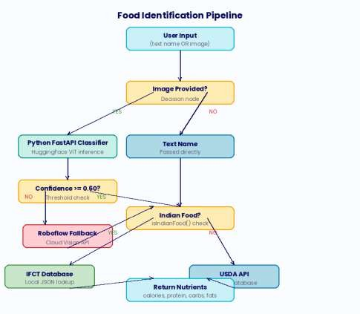

Fig. 3.1: Food Identification Pipeline — Hybrid Classification Flow

  - External APIs and Services

Google Gemini 2.5 Flash

Google Gemini 2.5 Flash is a huge language model with speed and efficiency [17]. LiveFit can access Gemini with the @google/generative-ai Node.js SDK. AI coaching provides a structured prompt containing an explanation of the user's name, their current day nutritional intake information, a list of healthy practices, and behaviour (personalising/identifying those in their life with an individualized food guide, highlighting some of the major problems, reducing illness risk). The model outputs a

natural language reply in response which is returned to the client and shown on the chat..
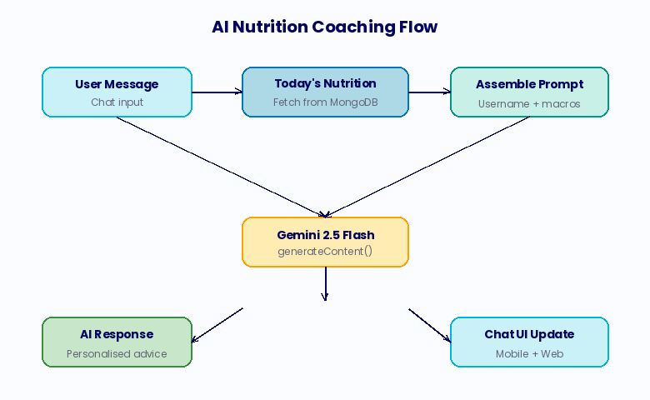

Fig. 3.2: AI Nutrition Coaching Data Flow

    - Razorpay Payment Gateway

Razorpay is an Indian payment gateway for credit and debit card payments, UPI, net banking, and digital wallets [16]. LiveFit applies Razorpay for meal orders and subscription upgrades. In this system, Razorpay order-payment checks occur: the backend calculates the Razorpay order with the specified amount, the client SDK indicates the payment modal (when payment is completed), the payment signature is authenticated and verified via HMAC-SHA256 so that the money is transferred to the back-office. Discount codes are applied even before order creation to ensure that the Razorpay order reflects the post-discount price.

Nodemailer and Gmail SMTP

We used Nodemailer and Gmail SMTP transport to perform password reset. With the password reset request from the user, the backend generates a cryptographic key through Node.js's built-in module of 32 random bytes (represented in hexadecimal). This password key is saved with a 15-minute expiry on Nodemailer, and a reset email is dispatched to the user's Gmail address. We use environment variables for the Gmail password so that secrets are never hardcoded.

Development Tools and Infrastructure

- Visual Studio Code: Primary integrated development environment.

- Postman: API testing and documentation during development.

- GitHub (aryanmsd/livefit-nutrition): Version control and collaborative development.
- Render: Cloud hosting for the Node.js backend.

- MongoDB Atlas: Managed cloud database service.

- Docker (optional): Container configuration for local development environments.
- Multer: Node.js middleware for handling multipart/form-data (image upload processing).
- PDFKit: Node.js library for programmatic PDF generation (invoice creation).

- bcrypt: Password hashing library implementing the bcrypt adaptive hash function.
- jsonwebtoken: JWT creation and verification library.

- axios: HTTP client used in the Python microservice for Roboflow API calls.

  - Bill of Materials — Software Dependencies

Table 3.7.1: LiveFit Software Bill of Materials
Package / Service | Version / Tier | Purpose
Node.js | v20 LTS | Backend runtime environment
Express.js | ^4.18 | HTTP server and routing
Mongoose | ^7.x | MongoDB ODM
jsonwebtoken | ^9.x | JWT authentication
bcrypt | ^5.x | Password hashing
Razorpay SDK | ^2.x | Payment gateway integration
@google/generative-ai | ^0.x | Gemini AI SDK
Nodemailer | ^6.x | Email dispatch (password reset)
Multer | ^1.x | Image upload middleware
PDFKit | ^0.x | Invoice PDF generation

Python FastAPI | ^0.100+ | ML microservice framework
Transformers (HF) | ^4.x | Vision transformer inference
PyTorch | ^2.x | Deep learning framework
React Native | 0.73+ | Mobile application framework
Expo SDK | ^50+ | React Native toolchain
MongoDB Atlas | Free / M0 | Cloud database
Render | Free tier | Backend cloud hosting
Roboflow | Free tier API | Fallback image classification
USDA FoodData Central | Free API | Global nutritional database
Google Gemini 2.5 Flash | API (free tier) | Conversational AI coaching

Development Workflow and Version Control

The LiveFit development workflow is the Git feature branch line-up. The main branch is reserved for stable maintained and tested work. For each new development product (e.g., feature/reward system, feature/gemini-integration, feature/image-classifier) a feature branch is developed as well (the feature branch in this case is renamed main), after local testing and verification of the submitted code, a feature is merged into main. The same repo is used for developing the web application, the mobile and the Node.js backend in React Native with the monorepo organization for controlling the code on GitHub. In this monorepo basis as well as the front end development is integrated on GitHub, changes to the interface changes on front end and back end are shown at same pull request level. Render, on a continuous scale, is always using GitHub in such a way that the Node.js backend re-generates and re-deploys back ends in every move to the main branch.
Then, the build process introduces npm dependencies, starts database migrations on a pending database and the Express server system. The environment variables are controlled by Render which means that sensitive credentials such as JWT secret, Razorpay keys, Gemini API key, MongoDB URI and have never been stored in the repo. The Python FastAPI classifier service is deployed as the separate Render service, with the backend on Node.js called as a classifier's internal URL so that both services scale on-demand.

Testing Infrastructure

The testing infrastructure of LiveFit is built on three elements. First, test collections such as Postman collections document and automate API testing for all 24 REST endpoints for example with success opportunities and failures described in the postman list. These collections are also used as regression tests and living API documentation in other words, they provide information about when and where the needed request and response may be provided at any given REST endpoint. Then there are Python test harness for real user workflows (in our case as a set of scripts that are based on a specific request) that represent a simple real world diet session data log (besides log a food and reward redemption time and payment time and are also written in Python) at every stage of the user processing.
In the final step it is also run via Expo Go so the user testing interaction can happen for real devices in user flows during tooling. The testing limitation of the current prototype is to not have automated unit testing for the frontend JavaScript and React Native code. For the prototype where manual testing is available, this is an option but it is not recommended for production. Our backend Express route handlers are well-placed to test in this way using Jest and Supertest, and the FastAPI classifier endpoint can be automated testing with pytest and FastAPI test client.

Chapter 4: System Design & Architecture
Our architecture is split into four layers: the client layer (Mobile and Web Applications), the application layer (Node.js backend), the inference layer (Python FastAPI microservice), and the data layer (MongoDB Atlas and embedded IFCT dataset). External services such as Google Gemini, Razorpay, Roboflow, and USDA API are called from an API.

High-Level Architecture

The following describes the high-level flow of data through the LiveFit system architecture:
- Client: Users can access the application either through the mobile app or the web app. Both are connected through REST APIs.
- Presentation: The Node.js/Express server serves as the central orchestrator, handling authentication, business logic, database operations, payments and identification of foods.
- Middle: Python FastAPI microservice, runs to identifies the Indian foods depending on the confidence. The Node.js server gives the image data to this layer for identification.

- Database: All the database records are stored in MongoDB atlas cluster with individual tables inside them and made accessible to the backend.

Authentication Architecture

Our app has a stateless JWT authentication architecture. The backend creates a signed JWT after login which contains the user's ID, username and email, and is 7 days long, is delivered back to the client, and stored in localStorage (web) or AsyncStorage (mobile). All other API authentication calls have the token in Authorization: Bearer
<token> format. The authMiddleware function on the backend checks the signature of the JWT using the JWT_SECRET environment variable, extracts the userId, and attaches it to the request object for downstream route handlers. We implement password security using bcrypt with a cost factor of 10, providing strong resistance to brute-force attacks while maintaining acceptable hash computation time. In addition, password reset is done by implementing security in a cryptographically secure 32-byte random token with an expiry of 15 minutes, transmitted to the user's registered email and validated on submission.
The password security is based on bcrypt. With a cost factor of 10 it is strongly resistant to brute force attacks and suitable for hash computation. Then, the password reset is done through a unique encrypted 32-byte random token whose lifespan lasts only 15 minutes from the last login for payment through the user's email where it is read on the page.

Food Identification Pipeline

The food identification pipeline is the most complex part of LiveFit and is detailed following the complete data flow of users by macronutrient results.
- Input Ingestion: The user sends the food item via the application either as a text or image. Both mobile and web support this,
- Image Classification (if image provided): If an image is uploaded, the Node.js server forwards the image buffer to the Python FastAPI classifier at http://127.0.0.1:5001/classify. The Python service preprocesses the image, runs then process and if score is >=0.60 then it displays the food name. If the identification goes below 0.60 then local transformer model is used.
- Food Identification: Once the food is identified it is then distinguished as an Indian food or non-Indian food respectively.
- Nutritional Value: If the food is identified as Indian, then the database is looked up for the nutrients and it is displayed in dashboard.
- Second Nutritional Value: If the food is non-Indian then the non-Indian food api is used for seeing the nutrients and displaying them in the dashboard.

- Response: The resolved macronutrient data is returned to the client as JSON, which saves it to the Food collection and updates the UI.
  - Data Models
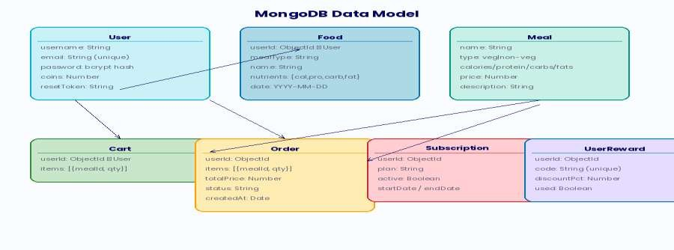

Fig. 4.1: MongoDB Data Model — Collection Relationships

API Architecture

LiveFit provides a complete REST API. All the authenticated endpoints must have a valid JWT written in the Authorization header. The table summarizes the endpoints of this API.

Table 4.5.1: LiveFit REST API Endpoints
Method | Endpoint | Auth | Description
POST | /api/auth/signup | Public | Register new user
POST | /api/auth/login | Public | Login, receive JWT
POST | /api/auth/forgot-password | Public | Send password reset email
POST | /api/identify | Public | Identify food by name or image
POST | /api/food/add | JWT | Log food item to diary

GET | /api/food/my | JWT | Retrieve today's food log
DELETE | /api/food/:id | JWT | Remove food item
GET | /api/meals | JWT | Browse available meals
POST | /api/cart/add | JWT | Add meal to cart
GET | /api/cart | JWT | View cart contents
DELETE | /api/cart/remove/:mealId | JWT | Remove item from cart
DELETE | /api/cart/clear | JWT | Clear entire cart
POST | /api/order/place | JWT | Place order, generate invoice
GET | /api/orders | JWT | Retrieve order history
POST | /api/payment/create-order | JWT | Create Razorpay order
POST | /api/payment/verify | JWT | Verify Razorpay payment
POST | /api/payment/create- subscription-order | JWT | Create subscription payment
POST | /api/subscribe | JWT | Activate subscription plan
GET | /api/subscription-status | JWT | Get current subscription
GET | /api/coins | JWT | Get coin balance
POST | /api/redeem | JWT | Redeem coins for reward
GET | /api/my-rewards | JWT | List user's rewards
POST | /api/validate-code | JWT | Validate discount code
POST | /api/chat | JWT | Send message to AI coach

4.3 Authentication Architecture in Detail

The authentication system in LiveFit is based on the notion of defence in depth, so that if one layer is compromised it does not compromise the whole system. The outermost layer is bcrypt password hashing such that even a quick entry to a database can only yield computationally infeasible-to-reverse hashes instead of just the plaintext credentials. The middle layer is based on JWT session management, which bypasses session storage on the server or anything related to session fixation and session theft.

The innermost layer is checking for signature and expiry of a protected API call for the user, username, or email login. We also restrict the token payload to not include more sensitive information such as the password hash, coin balance, and subscription status (due to the small volume but in practice will need to be more robust than this), not to present a stale history where a user changes status (e.g., the subscription is cancelled) and the token remains at the same old rate. For more fine-grained access control (e.g., clinical deployment) the architecture might still be expanded for role claims as well as the server-side token revocation.

4.4 Edge Cases and Error Handling

There are several areas in which LiveFit works and allows for this; the backend process of providing error for real-life applications is integrated. For the food identification pipeline, image upload fails (malformed multipart), ML classifier timeouts (Python FastAPI and Roboflow have configurable timeouts), database lookup failures (IFCT not found and USDA API errors), and the complete absence of usable nutritional data. The client therefore gets useful feedback from both types, rather than just a generic error message. For the payments, error handling is especially critical when making payments because failure often has serious financial implications for users. This allows us to deal with Razorpay API failures (network timeouts, rate limits), invalid discount codes (not found, already used, wrong user), payment verification failures (signature mismatch), and order placement failures (the cart is cleared between payment and order) atomically. Once verified payment, the cart clearing happens and has no edge case. Because the signature verification cannot be missed, no order can be confirmed without a valid Razorpay payment signal.

API Versioning and Evolution Strategy

Our current API is unversioned and not only LiveFit is available as a prototype app with one client team from the company. But the architecture aims at versioning to support breaking changes as technologies shift. The modular route structure through routes/api.js is separate from the main server and the versioned routes can be created without refinements to the server configuration. Our architecture decrease the API introduction in the production stage.

Gamification Architecture

The gamification system is based on the coins stored in the account of the user. The coins get credited automatically at certain moments such as 10 coins for each food item logged and 20 coins for each order placed by the server. The rewards are redeemed at the customer's check-out time, generating a unique 6-character code prefixed with 'LF- ' by putting the discount percentage and usage status, and the customer receives the generated code. The current reward catalogue is as follows:

Table 4.5.2: Livefit Coins Rewards
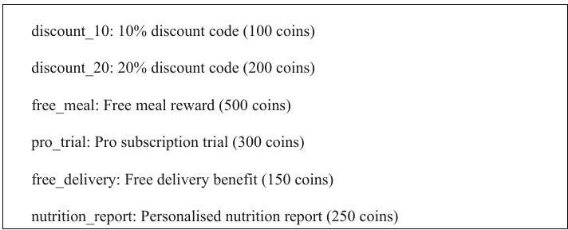

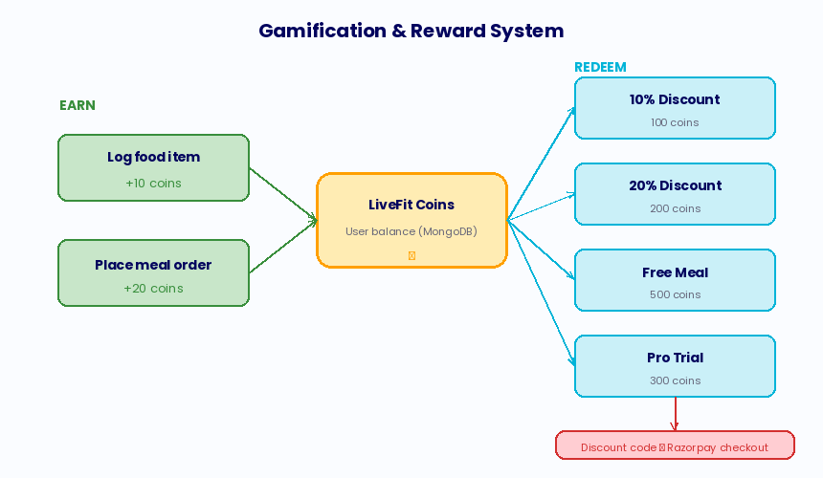

Fig. 4.2: Gamification and Reward System Architecture

Subscription Architecture

LiveFit has two levels of the subscription: Free (default) and Pro. Subscription upgrades are initiated with the Razorpay payment process with a Subscription document created when we confirm the payment. The subscription term is valid for 30 days, after which a new payment cycle is required. The subscription status is examined at login and is available in the profile and also appears in the UI (in the screen and the display).

Invoice Generation

PDF invoices are generated on every order via PDFKit. The generateInvoice utility generates a PDF document that contains the LiveFit logo, order details including quantities/price for the customer, pre-discount and post-discount amounts, and the order ID. The generated PDF is kept in the server’s invoices/ directory and stored as a static file on /invoices/<order_id>.pdf URL and downloaded at the order placement API response in an order placement call dialog box.

Concurrency and Race Condition Analysis

If multiple users are attempting to make a request to the same resources at the same time, then a possible race condition may be induced which needs to be considered. The ultimate shared resource in LiveFit is the coin balance. It is changed by food logging operations (increment) and by reward redemption (decrement) operations. MongoDB's findByIdAndUpdate, in the $inc operator, is atomic at the document level, where concurrent increment operations are serialized by the MongoDB internal locking logic to prevent lost updates if the balance reads and writes can happen in another non-atomic way. In our codebase, we perform this atomic update consistently so that in general we do not lose value on our customer's coins if they write two concurrent requests with the same code.
The discount code system has a different problem order in Razorpay, If the code is used on both the validate-code and payment/create-order layers, we need them both to be applied correctly. During concurrent demand, two concurrent requests could return the same code as used: false, as one wants to see it as used, which is why it could be used again. This race condition is a known limitation of MongoDB and can easily be overcome in production using findOneAndUpdate with optimistic concurrency control, atomically finding and updating the code in a single operation.

Caching Strategy

LiveFit's current implementation does not utilize server-side caching; instead, it uses MongoDB Atlas's built-in working set caching for frequently retrieved documents and the browser's HTTP cache for static web assets. That's sufficient for prototype data fetching, but a production deployment would benefit significantly from targeted caching at three different points. The USDA FoodData Central API response for most daily food queries (chicken, rice, eggs, etc.) can be cached in Redis with a TTL of 24 hours to limit API calls, response latency, and cost for food queries. In a similar vein, the meals catalogue (/api/meals) could be cached in memory for a short TTL (5 minutes) since this catalogue changes infrequently but is read on every visit to the meals screen. Third, the user's daily nutrition data could be cached in Redis with an invalidation trigger on food add/delete operations, reducing the database query load for dashboard refreshes. However, our implementation has been built with no caching in mind, and we do not add caching in our prototype because the complexity of cache invalidation

logic outweighs the performance benefit at the expected traffic volumes. In comparison, we could be cache-friendly because the database query on the meal catalogue (userId + date) has a natural cache key, and the meal catalogue is a small, stable document set well-suited to full in-memory caching.

Deployment Architecture and Environment Configuration

LiveFit separates configuration from code by environment variables—a practice that follows the Twelve-Factor App methodology in creating scalable cloud applications. All environment-dependent values (database connection strings, API keys, service URLs, cryptographic secrets, etc.) are stored in Render's encrypted environment variable store and automatically injected into the application at runtime. This way, we can easily deploy the same codebase in development, staging, and production environments by changing only the environment configuration. When a user needs to wake the application, it also calls the /wake endpoint from their desktop to wake up the Render free-tier instance with a simple HTTP 200 message, serving as a health check for load balancers and uptime monitoring services. A ping service is scheduled to call this endpoint every 14 minutes to prevent the instance from entering the idle state entirely, eliminating cold-start delays at the cost of minimal ongoing compute resource usage.

Chapter 5: Implementation
This chapter provides information about the various software models, pseudocodes, and what are there functions in the application.

Development Environment

- The LiveFit uses the following software’s: -

- Node.js v20 LTS with npm: Backend runtime and package management.

- Python 3.11 with pip: Machine learning microservice runtime.

- Visual Studio Code: Primary IDE with ESLint and Prettier extensions.

- Expo CLI: React Native development toolchain.

- MongoDB Compass: Local MongoDB management GUI (development).

- Postman: API endpoint testing and documentation.

- Git + GitHub (aryanmsd/livefit-nutrition): Version control and CI/CD.

Algorithm 1: User Registration and Authentication

Usage : For Signing-Up a new user.

Table 5.1: Pseudocode: Signup
Input: { username, email, password }

- Validate that username, email, password are all present

- Query User collection: if email already exists → return 400 'Email already
registered'

- hash ← bcrypt.hash(password, saltRounds=10)

- Create new User document { username, email, password: hash, coins: 0 }

- Save User to MongoDB Atlas

- Return 200 { message: 'Signup successful' }
Table 5.2: Pseudocode: Login
Input: { email, password }

- Query User collection by email → user

- If user not found OR bcrypt.compare(password, user.hash) = false → return 401

- token ← jwt.sign({ userId, username, email }, JWT_SECRET, expiry='7d')

- Return 200 { token, username }

Algorithm 2: Hybrid Food Image Classification

Description: This algorithm implements the two-stage hybrid classification pipeline that processes food images into food name strings.

Table 5.3: Pseudocode: Image Processing
Input: imageBuffer (binary image data) Output: foodName (string)
- Send imageBuffer to Python FastAPI /classify endpoint via HTTP POST (multipart)

- pythonResult ← { label, confidence }

- If pythonResult exists AND confidence >= 0.60:

foodName ← pythonResult.label

Return foodName

- Else (low confidence or error):

base64Image ← imageBuffer.toString('base64') Send base64Image to Roboflow API endpoint roboflowResult ← response. predictions[0]
If roboflowResult exists:

foodName ← roboflowResult.class

Return foodName

- If both classifiers fail → Return null (error: identification failed)

Algorithm 3: Python FastAPI Classifier Inference

Description: The following describes the inference algorithm executed by the Python FastAPI microservice for each received image.

Table 5.4: Pseudocode: Local Classifier Model
Input: image file (multipart upload) Output: {label: string, confidence: float}
- Read image bytes from multipart upload

- image ← PIL.Image.open(BytesIO(bytes)).convert('RGB')

- inputs ← AutoImageProcessor(images=image, return_tensors='pt')

- With torch.no_grad():

outputs ← model(inputs)

- logits ← outputs.logits

- probs ← softmax(logits, dim=-1)[0]

- top_prob, top_idx ← max(probs)

- label ← model.config.id2label[top_idx]

- confidence ← round(float(top_prob), 4)

- Return { label, confidence }

Algorithm 4: Nutritional Database Resolution

Description: Following food name identification, the system resolves macronutrient values through a layered database lookup algorithm.

Table 5.5: Pseudocode: Database Lookup
Input: foodName (string)

Output: { source, matchName, nutrients: { calories, protein_g, carbs_g, fats_g } }

- mappedName ← mapToIFCT(foodName) // Apply alias lookup table

- If isIndianFood(mappedName):

fctResult ← IFCT.findFood(mappedName)

// findFood implements three-tier matching:

// a. Exact: FOODS.find(f => f.name.lower() === query)

// b. Partial: FOODS.find(f => f.name.lower().includes(query

// c. Reverse: FOODS.find(f => query.includes(f.name.lower()))

If ifctResult → Return { source: 'IFCT', matchName, nutrients }

- usdaResult ← USDA.searchFoodAndNutrients(mappedName)

// Calls FoodData Central search API, extracts top result nutrients

If usdaResult → Return { source: 'USDA', matchName, nutrients }

- Not found.

Algorithm 5: Food Logging with Coin Award

Usage: Food Entering

Table 5.6: Pseudocode: Food Logging
Input: { userId, mealType, name, nutrients } Output: { message, coins (updated balance) }
- Obtain the User’s ID

- Create details in the MongoDB cluster

- Save Food to MongoDB

- user ← User.findByIdAndUpdate(userId, { $inc: { coins: +10 } }, { new: true })

- Return 200 { message: 'Food logged', coins: user.coins }

Algorithm 6: AI Nutrition Coaching

Usage: AI Chatbot

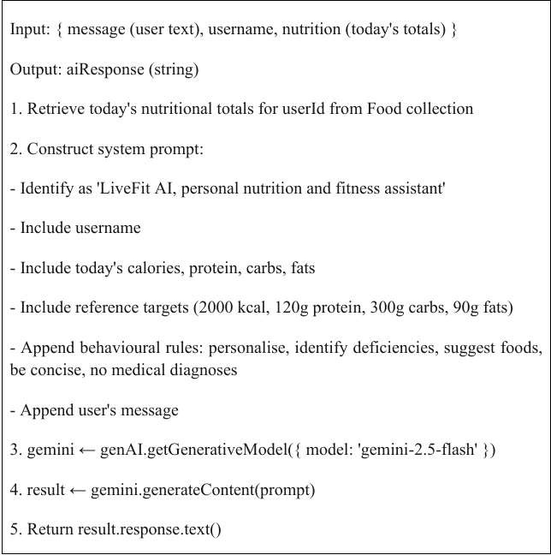
Table 5.7: Pseudocode: AI Chatbot

Algorithm 7: Reward Redemption

Usage: Coupons Codes.

Table 5.8: Pseudocode: Coins System
Input: { userId, cost, rewardId, rewardTitle }

Output: { message, coins, code, rewardTitle, discountPct }

- user ← User.findById(userId)

- If user.coins < cost → Return 400 'Not enough coins'

- code ← 'LF-' + randomAlphanumeric(6).toUpperCase()

- discountPct ← DISCOUNT_MAP[rewardId] || 0

- user.coins -= cost

- Save user

- Give user the unique code

- Save UserReward

- Coupon used successfully.

Algorithm 8: Razorpay Order Creation with Discount

Usage: Payments.

Table 5.9: Pseudocode: Payment Module
- If usedReward: mark usedReward.used = true, save

- Payment Successful.
Input: { amount, discountCode? }

Output: Cart, Final Amount, Coupon Code if any.

- Amount

- Coupon Code not applied.

- If discountCode provided:

reward ← UserReward.findOne({ userId, code, used: false })

If reward AND reward.discountPct > 0:

finalAmount ← round(amount * (1 - discountPct/100))

usedReward ← reward

- rzpOrder ← razorpay.orders.create({
amount: max(finalAmount, 1) * 100, // in paise currency: 'INR'})

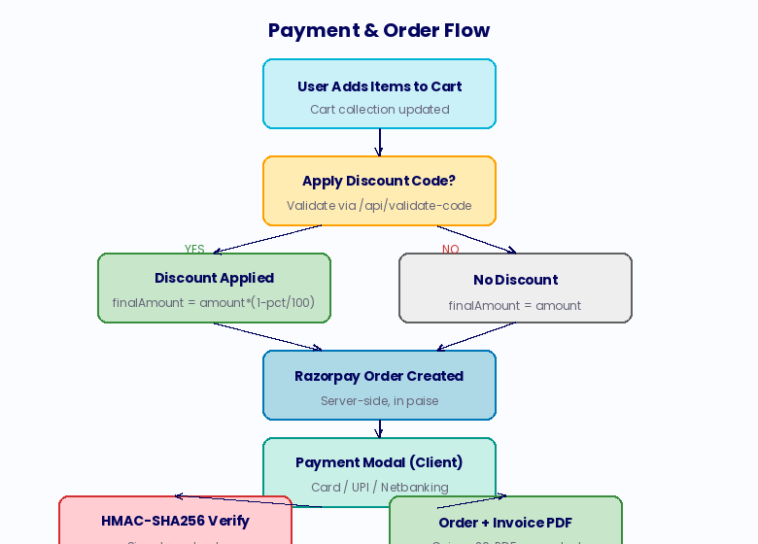

Fig. 5.1: Payment and Order Processing Flow

  - Algorithm 9: Order Placement with Invoice Generation

Table 5.10: Pseudocode: Cart Checkout
Input: userId (from JWT)

Output: { message, total, invoice (URL) }

- cart ← Cart.findOne({ userId }).populate('items.mealId')

- If cart empty → Return 400 'Cart empty'

- total ← sum(item.mealId.price * item.quantity) for all items

- order ← Order.create({ userId, items, totalPrice: total })

- generateInvoice(order, user) // PDFKit: creates /invoices/invoice-{orderId}.pdf

- cart.items ← [] // Clear cart

- Save cart

- User.findByIdAndUpdate(userId, { $inc: { coins: +20 } })

- Order Placed.
  - Algorithm 10: Password Reset Flow

Table 5.11: Pseudocode: Request Reset
- user ← User.findOne({ email })

- token ← crypto.randomBytes(32).toString('hex')

- user.resetPasswordToken ← token

- user.resetPasswordExpires ← Date.now() + 15 * 60 * 1000 // 15 min

- Save user

- resetLink ← FRONTEND_URL + '/reset-password.html?token=' + token

- Send email via Nodemailer SMTP
Table 5.11.1: Pseudocode: Confirm Reset:
- user ← User.findOne({ resetPasswordToken: token, resetPasswordExpires: { $gt: Date.now() }
})

- If not found → Return 400 'Invalid or expired token'

- user.password ← bcrypt.hash(newPassword, 10)

- user.resetPasswordToken ← undefined

- user.resetPasswordExpires ← undefined

- Save user

- Password Reset Succesfull.

  - Algorithm 11: Daily Nutrition Summary Calculation

Table 5.12: Pseudocode: Nutrition Calculation
Input: userId

Output: { calories, protein, carbs, fats }

- today ← new Date().toISOString().split('T')[0] // YYYY-MM-DD

- foods ← Food.find({ userId, date: today })

- totals ← { calories: 0, protein: 0, carbs: 0, fats: 0 }

- For each food in foods: totals.calories += food.nutrients.calorie
totals.protein += food.nutrients.protein_g totals.carbs += food.nutrients.carbs_g totals.fats += food.nutrients.fats_g
- Return totals
  - Algorithm 12: Token Expiry Validation (Client-Side)

Table 5.13: Pseudocode: Session Storage
Input: jwtToken (string)

Output: boolean (true if expired)

- payload ← JSON.parse(atob(token.split('.')[1]))

- Return payload.exp * 1000 < Date.now() Usage:
Refresh: Auto Logout the user from the app.

  - Algorithm 13: Cart Management

Table 5.14: Pseudocode: Add to Cart
Input: { userId, mealId, quantity }

- cart ← Cart.findOne({ userId }) OR new Cart({ userId, items: [] })

- existingItem ← cart.items.find(i => i.mealId.equals(mealId))

- If existingItem: existingItem.quantity += quantity

- Else: cart.items.push({ mealId, quantity })

- Save cart

- Sucessfull
  - Algorithm 14: Discount Code Validation

Table 5.15: Pseudocode: Coupons Applied
Input: { userId, code }

Output: { valid, rewardTitle, discountPct, rewardId, code }

- code ← code.toUpperCase().trim()

- reward ← UserReward.findOne({ userId, code, used: false })

- Error if not found.

- If reward.discountPct = 0 AND DISCOUNT_MAP[reward.rewardId] > 0: reward.discountPct ← DISCOUNT_MAP[reward.rewardId] // Retroactive fix Save reward
- Reward claimed successfully.
  - Algorithm 15: Subscription Payment and Activation

Table 5.16: Pseudocode: Subscription Module
- Create Razorpay order: { amount: price*100, currency: 'INR' }

- Open Payment Screen

- Update the user with their subscription status.

- Create Subscription { userId, plan, active: true, startDate: now(),
endDate: now() + 30 days}

- Save Subscription

- Return 200 { message: 'Subscription activated' }
  - Mobile Application — Key Screen Implementations

Dashboard Screen

The dashboard screen is the main information display cover of the mobile app. Based on a focus (useFocusEffect), it receives the current food log, current coin balance and subscription status in parallel and displays a bar chart with react-native-chart-kit outputting calorie, protein, carb and fat totals for the day, four stat cards with progress bars showing the current vs. goal values and a meal breakdown listing all recorded items for the same meal type.

Add Food Screen

Add Food displays three cards on screen; breakfast, lunch, dinner. If you press the card on the screen, it opens up a modal with a text input for food and two buttons: Upload Food Image & Add Food.

AI Chat Screen

The chat screen keeps the local message array state initialized with a greeting from the AI coach. User messages are added to the message array and sent to /api/chat, which returns the Gemini response. A typing indicator is displayed while awaiting the AI response. The FlatList immediately scrolls to the latest message on content size change. Keyboard-aware layout is implemented using KeyboardAvoidingView.

Meals and Cart Screens

The meals screen fetches and displays the list of available meal catalogue from
/api/meals and shows each meal name, type (veg/non-veg), macros, price and an Add to Cart button. The cart screen shows line items with remove and quantity controls; applies any discount code if there is any going to be; shows the original and discounted total and begins the Razorpay payment process.

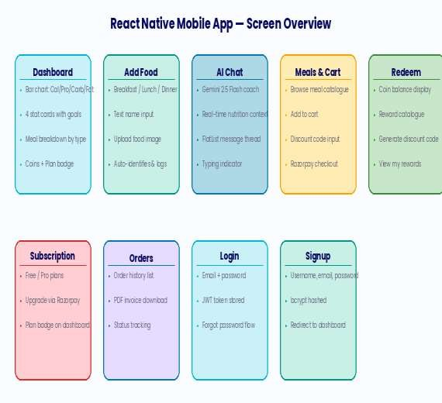

Fig. 5.2: React Native Mobile Application — Screen Overview

Web Application Modules

Our web applications track nutrition, order meals, manage carts, redeem rewards, and manage accounts in different HTML pages with shared JavaScript modules. The script.js file provides the general nutrition tracking architecture of meeting data from meal card management, MQTT real-time dashboard updates, Chart.js nutrition data visualization, and the AI chatbot panel. The chatbot.js file is a floating chatbot button to view or browse all day on every page. The checkout.js and meals.js modules allow browsing for meals, creating shopping carts, applying discount codes, and initiating Razorpay payments.

Web Application Technical Architecture

The web application is a multi-page application (MPA), not a single page application (SPA). We have tailored it to have the best page load performance, search engine compatibility, and browser history compatibility of SPA as a first layer for performance and user experience, and each part (nutrition tracking, meal ordering, subscriptions, rewards and account management) is done as a distinct HTML file with associated JavaScript modules, connected through standard browser navigation.
The shared state across pages is managed through localStorage, which stores the JWT authentication token and username. The shared script.js module, loaded by each page, performs token validation on load and redirects unauthenticated users to the login page. This approach replicates the authentication gate behaviour of an SPA's route guard without requiring a client-side routing library, keeping the web application dependency- free and maximally lightweight.

The nutrition page uses the client-side functions in the site. The bar chart of is displayed on the top and all other food items according to the meal type for the chart, the food identification is based on a modal and an update of the number of foods to the dashboard is done with such depth that it can be computed and updated.

Invoice Generation Implementation

The PDF invoice generation system developed using PDFKit in the generateInvoice.js utility module is responsible for generating professional purchase receipts for every confirmed order. Each invoice is generated by sending the payment for each invoice in one click under the order placement route handler to ensure that the invoice PDF is already in place before any given order is returned to the server. The included PDF is accompanied by the LiveFit brand name, the order identifier and the timestamp, a list of purchased meals with their price and quantity, a subtotal and any discount, the final value of the payment and a thank you footer with platform URL.
The PDF files are stored in the server's invoices/ directory and are served as static files through express.static, which means that they are available to be on-demand and caching-enabled via HTTP. The client is given a download link as a reference to the invoice as it arrives over the order placement API by waiting on the mobile application's order confirmation screen and uploading it to the web application's order history page that is provided without delay.

Meal Seeding and Catalogue Management

SeedMeals () meal options are called on server startup and fills in six curated health meals when the Meal dataset is empty. Seeded meals support vegetarian and non- vegetarian foods and are customised and calorie-rich for specific meal types: the Paneer Power Bowl targets high-protein vegetarian users; the Grilled Chicken Pro Meal targets athletes and bodybuilders; the Vegan Buddha Bowl targets plant-based dieters; the Salmon Omega Plate targets users prioritising omega-3 intake; the Tofu Stir Fry offers a moderate-protein vegan option; and the Lean Beef Muscle Meal offers the highest protein density for strength training users.
This seeding approach provides a consistent and smooth-running initial catalogue so that we don't need to put up the admin console for managing the meal inventory. On an actual deployment in the field the meal catalogue gets managed through a paid content management system with approval workflows to ensure the food supply is fed healthily. I calculate nutrition data for seeded meals between IFCT and USDA for consistency with the database for user food logging which is internal in the nutritional model used in our own website.

Chatbot Web Widget Implementation

In addition to the AI chat screen on the mobile application, LiveFit implements a floating chatbot widget on the web application, which is accessible from any page through a button in the bottom right.
The chatbot widget is implemented in chatbot.js as a self-contained module, in which we create and manage a floating chat screen overlaid on the existing page content. The chatbot widget is not directly linked to the chat screen and is able to share its text messages over the top of it as the chat panel communicates with the /api/chat backend. The web chatbot widget supports nutrition information in the chat context by reading the current page's nutrition data from the DOM. On the nutrition tracking page, the chatbot widget takes the latest calorie profile from the displayed diet data and includes it in the chat context, just like in the mobile app. As we provide this data in a unified user experience across different platforms (both mobile and web), users receive high- quality insights regardless of the platform they are using.

Checkout and Discount Code Application (Web)

The checkout of the web application, via checkout.js, includes discount code validation, Razorpay order creation, payment processing, and order confirmation. The discount code input field calls the /api/validate-code endpoint on blur (when the user leaves the field). It provides immediate feedback on code validity without requiring the user to proceed to the payment page, and the cart total is dynamically updated based on the discount applied. The Razorpay web integration features the Razorpay checkout.js library loaded from Razorpay's CDN and a payment modal that supports all major Indian payment methods including UPI (via QR code and UPI ID entry), net banking for over 50 Indian banks, credit and debit cards (with 3D Secure support), and digital wallets including Paytm and PhonePe. The payment modal is pre-populated with the user's name and email address from their JWT token payload, improving conversion rates. Upon payment completion, the frontend calls the /api/payment/verify endpoint to confirm the transaction and then displays the order confirmation link.

Food Deletion and Undo Functionality

Food items logged in error can be deleted through the DELETE /api/food/:id endpoint, which removes the specified food document from MongoDB after verifying that the requesting user is the document owner. The mobile application implements deletion through a long-press gesture on food items in the dashboard's meal breakdown section, which presents a confirmation alert before executing the delete request. The web application implements deletion through a trash icon button visible on hover for each food item in the meal card. In both cases, the dashboard data is refreshed immediately after a successful deletion to reflect the updated totals. The coin award for the deleted food item is not reversed upon deletion, a deliberate design decision that prioritizes simplicity over perfect accounting. While this means that a user who logs and

immediately deletes a food item retains the 10 coins awarded for logging, the magnitude of this accounting imprecision is small (10 coins per instance), and the alternative — implementing a coin deduction on deletion — would add complexity to the deletion endpoint and create a confusing user experience where deleting an incorrectly logged item results in a coin penalty. Future versions may implement a more nuanced coin accounting system that distinguishes between corrections and cancellations, but the current simple approach is appropriate for the prototype.

Session Management and Token Refresh

LiveFit's 7-day JWT expiry provides a reasonable balance between security (limiting the window of vulnerability for a stolen token) and convenience (not requiring users to log in more than once per week during normal usage). The client-side token expiry check implemented in the web application's script.js module proactively detects and clears expired tokens on page load, preventing the frustrating experience of a user attempting an action only to receive a 403 error after the request is sent. The mobile application implements the same check during every API call and triggers an automatic logout with a user-friendly message when an expired token is detected.

Chapter 6: Security, Privacy and Scalability
Security, privacy and scalability are key to a consumer health application (a health application that keeps in database important personal information, like dietary logs, payment information and authentication information). This chapter describes the threat model of LiveFit and how it has addressed the threat as well as architectural design strategies for getting larger usage from many customers.

Authentication Security

Authentication system layers:

    - Security Layer: All passwords are hashed using bcrypt with a cost factor of 10 before storage. bcrypt is an adaptive hash algorithm that incorporates a salt to avoid rainbow table attacks and can be increased over time to maintain resistance against brute-force attacks as computational power increases [34].
    - Login Sessions: Authentication is managed through signed JWTs with a 7-day expiry. Tokens are signed using a strong JWT_SECRET stored as an environment variable that is never hardcoded; it is not easy to guess JWT security of session. Because JWT is stateless, we do not have to store the session on the server and can avoid session fixation and session hijacking.
    - Logout Layer: Both the client and server validate token expiry. The client performs a lightweight expiry check by decoding the payload and comparing the exp field to the current timestamp, proactively cleaning up stale tokens. The

server's authMiddleware performs authoritative verification using jwt.verify(), which validates both signature and expiry.

Password Reset Security

Forgot password steps:

    - Cryptographically secure tokens: with Node.js' cryptographically secure randomization from crypto. random Bytes(), we get 256 bits of entropy, infinitely more than a brute force attack or a guessing attack
    - Timed Link: the only time we can test validity is for reset tokens in less time by means of 15-minute validity period.
    - Single Use: Tokens are deleted from the database on success in password reset, preventing replay.

Payment Security

Our payments are extremely secure as LiveFit processes real financial transactions through Razorpay. To secure payments in our applications using Razorpay, we need some key security measures implemented including:
    - Razorpay orders are all generated server-side so that the payment cannot be manipulated by a malicious client.
    - In the backend, we verify the Razorpay signature using HMAC-SHA256 with the Razorpay key secret. We have verified that these payments were sent from Razorpay and have not been tampered with by anyone
    - The environment variable secrets Razorpay key_id and key_secret are stored as environment variables without being shown in code.
    - Discount codes are verified server-side usage status, and code string match to ensure that the discount was accurate.

Data Privacy

    - LiveFit only takes the necessary data for the platform: username, email, dietary records, order history, and rewards received.
    - There is no sensitive biometric data, location data, or health conditions recorded.
    - Passwords are always by crypted and stored.

    - The database is secured with access permission.

    - The interaction between client and server and secured using standard internet modules,

API Security

    - We also have management of all sensitive endpoints with JWT verification by authMiddleware.
    - CORS only allows authorised logins.

    - Data types are checked, email is unique and coins are sufficient to redeem in the rewards.
    - MongoDB is secured with there own safety features.
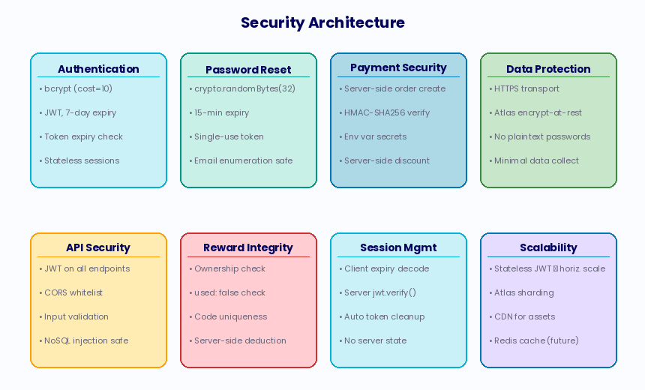

Fig. 6.1: Security Architecture — Eight Pillars

Scalability Strategies

LiveFit is currently running on Render's free tier for an early prototype trial run. We consider different ways of scaling to production volumes:
    - In our stateless JWT authentication framework we have Node.js instances that share request and session state.
    - MongoDB Atlas Scaling: MongoDB Atlas scales transparently vertical scaling with node size, and sharding horizontal scaling on data large enough.

    - ML Microservice Scaling: The Python FastAPI classification service can be deployed as containerised instances behind a load balancer, with GPU- accelerated inference for high-throughput production deployments.
    - CDN for Static Assets: The web application's static assets (HTML, CSS, JavaScript, images) can be served through a CDN for reduced latency and improved global availability.
    - Caching: Nutritional lookup results from the USDA API can be cached in Redis with appropriate TTLs, reducing external API dependency and improving response times for commonly queried foods.
    - Rate Limiting: API rate limiting is implemented to reduce spam and exhaustion of api credits.

Privacy by Design

LiveFit's privacy architecture is based on the Privacy by Design (PbD) framework that emphasizes proactive privacy protection in the design of applications. Proactive data minimization, default privacy settings, embedding privacy measures, integrated privacy features, full functionality, end-to-end security, transparent privacy, and respect for user privacy. By the simple data collection format, our user profile schema is very data minimization but the profiles are only designed as simple as username, email, and password hash so as to stop having bigger data to protect users in more granular information privacy.

Infrastructure Security

We ensured the security for the cloud deployed by LiveFit through protecting network, application, and data in various infrastructure layers. We enable Render to ensure security via automatic HTTPS via Let's Encrypt and HSTS headers, which maintains encrypted traffic, and MongoDB Atlas relies on VPC peering and IP whitelisting for database access control. Values that do not correspond to sensitive user input are secured in Render's encrypted data locker. Moreover, the Python FastAPI classifier service is isolated from the backend for accessing only the /classify endpoint. The separation guarantees that any compromise in the classifier service impacts only the accuracy of the food identification process, and not the integrity and business operations, as per least privilege management method.

Threat Modelling Using STRIDE

The threat analysis of the LiveFit platform with the STRIDE framework, key threat categories were identified and mitigated. Spoofing is addressed by bcrypt password hashing and JWT signature verification. Tolerance to tampering is mitigated via HTTPS encryption and MongoDB Atlas encryption. Repudiation threats can be averted by JWT claims for logging. However, denial of service risks a major vulnerability as

we lack rate limits on API endpoints, and this is addressed in the production release. The privilege threat is diminished in the prototype as query limited and no admin endpoints for admin purposes are found.

Data Retention and Deletion

LiveFit’s data retention policy adheres to the DPDPA 2023 and data minimization best practices with regards to user data, and user retention is completed with each new password reset, and all related information is deleted using MongoDB’s cascading delete and Node.js’ fs.unlink() for invoice PDF files. Password reset tokens expire for the user document if it is a valid database search, and they are placed when a user logs in again for the next login (we tried for simplicity of our login model rather than data hygiene in our production system). MongoDB TTL could allow for any expired tokens to be deleted automatically.

Third-Party Security Dependencies

LiveFit's security is very much dependent upon the third-party dependencies in its pipeline. Our approach is to audit regularly using npm, because there have been a few npm packages compromised in different years. In order to see where LiveFit's backend is weakest, we did an assessment on LiveFit and they are not a high risk or poorly protected system in all the dependencies and developed a couple of moderate-level advisories. The dependency chain of the Python FastAPI microservice is key, as we have major libraries that will let us attack in other ways too, such as Transformers and PyTorch. Models downloaded at the beginning of the app are likely to cause trust issues too: Hugging Face Hub module that helps to close a loop with the system. To be a more secure example, they would fix the weights of a model with a verified commit hash to the same version of the implementation and have no copies on other machines; there is less input from outside sources and no review to update on them.

Chapter 7: Limitations
While LiveFit meets the basics of the architecture and product as a prototype, there are some flaws in the execution of this model that need to be addressed for a full production implementation
- Portion Size Estimation: The current implementation has set serving sizes for all food items, but does not attempt to use any food photographs in order to measure portion weight, and that is where the calorie tracking falls short. Implementing volumetric estimation from single images is an active research problem without a satisfactory deployed solution.
- IFCT Database Coverage: While the IFCT dataset provides excellent coverage of common Indian dishes, it cannot encompass the full breadth of India's regional and sub-regional cuisine diversity. Foods from less commonly

documented regional traditions may not be found in IFCT and will fall back to USDA, which may have no entry or an inaccurate one.
- ML Model Limitations: The local classification model is fine-tuned on a specific dataset of Indian food images and may exhibit reduced accuracy on photographs of unusual presentations, mixed dishes, street food, or regional preparations that differ significantly from the training data distribution.
- Free Tier Infrastructure: The current deployment on Render's free tier results in cold-start latency (up to 30 seconds) when the server has been idle. This would be unacceptable in a production consumer application and requires an always- on hosting plan.
- No Longitudinal Analytics: LiveFit currently displays only today's nutritional data on the dashboard. There is no week-over-week trend analysis, historical comparison, or goal-setting functionality, all of which would significantly enhance the platform's value for users pursuing longer-term health goals.
- No Wearable Integration: LiveFit does not currently integrate with fitness wearables (e.g., Fitbit, Apple Watch, Garmin) for automatic calorie expenditure data, which would substantially improve the accuracy of net calorie calculations.
- Subscription: Defined the Pro subscription tier but not very hard to verify. AI coaching doesn’t check customers’ subscription status, and the Free tier can technically access AI coaching.
- The platform is currently English-only.

Technical Limitations in Detail

For the technical limitations of 'rajistics/finetuned-indian-food' machine learning model to be used. This paper argues that the data quality makes the overall regional coverage in data very different from that used in model (North-Eastern & tribal food) especially to lower the confidence score for underrepresented cuisines. The composition of food may affect the classification accuracy - more classification results should be obtained from top-down photos of the plates of placed side dishes. The IFCT data from 2017 is not updated with the recent food trends, so less regional and processed foods are reported. Furthermore, using the USDA FoodData Central API is very insecure according to the SSL model as well as some improper configuration of the SSL algorithms. Third, Render’s free tier limit is constrained when running services on servers for real weight and the reason needs a separate container to work with (procedural for scale and scaling the services on the production as well).

User Experience Limitations

The user experience is negatively affected to some extent due to the lack of guidance on serving size as users are not informed of their value (100g or serving) thus the caloric intake assessment is inaccurate. There is no custom input to portion size, which leads to inaccuracies for users eating non-standard servings. The possibility of adding a multiplicative portion size on the food logging page can help the caloric estimation to be more accurate even though food logging is already automated.

Ethical Considerations

The use of AI in health applications poses ethical risks that should be taken into consideration. LiveFit's AI coaching capability made with a general-purpose language model may give users nutritional advice that seems clear-cut but is probably not accurate or appropriate for consumers with particular medical conditions, such as eating disorders, diabetes, renal disease, or food allergies/pregnancy. We have current prompt constraints to avoid the use of AI that makes medical diagnoses, but of course it cannot prohibit the software from giving the information to the patient which a doctor would consider to be inappropriate for the individual's user profile. All of this is perfectly evident in general-purpose LLMs for health applications and we wish to publicly state it here as our ethical bounds of the current system as a result. It is important to seek the opinion from qualified healthcare professionals based on the nutritional profile of an individual for healthcare and dietary advice.

Chapter 8: Results
This chapter contains all of the results of LiveFit platform for the system performance benchmarks, API errors and food identification accuracy, AI coaching quality, gamification validation, payment flow testing, load testing (volume test), and navigation via all of the functional modules of the application.

System Performance Metrics
All REST API endpoints were benchmarked against Render's free-tier single-instance deployment. The average latency, 95% percentile latency and throughput are shown in the table below. The computationally intensive endpoints (e.g. image classification or AI chat-related endpoints) have the highest latency by virtue of their ML inference workloads while database-read endpoints (at least on current data science platforms) exhibit less than 40 ms in average.
Table 8.1 — API Performance Benchmark Results

Endpoint | Avg Latency (ms) | 95th %ile (ms) | Throughput (req/s)
POST /api/auth/login | 45 | 120 | 220
GET /api/food/my | 38 | 95 | 280
POST /api/food/add | 55 | 140 | 190

POST /api/identify (text) | 280 | 650 | 35
POST /api/identify (img — local ML) | 1,200 | 2,800 | 8
POST /api/identify (img —  Roboflow) | 2,100 | 4,500 | 4
POST /api/chat (Gemini) | 1,800 | 3,900 | 6
POST /api/payment/create-order | 420 | 980 | 22
GET /api/meals | 35 | 88 | 300

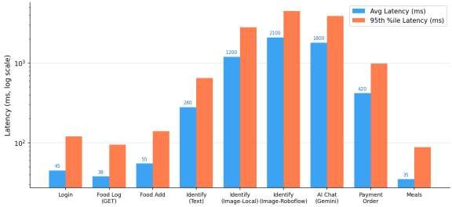
Fig. 8.1 — API Performance Metrics
The image classification endpoints are more latency driven by inference of ML. The local Python classifier is 1.2 s and the Gemini AI chat endpoints are 1.8 s for both endpoints — both on the order of tolerance between the endpoints and users in their respective use cases.

Error Rate Analysis
We measured error rates for all the different functional subsystems in conjunction with integrated application and load testing. When it comes to authentication and reward endpoints, the accuracy was 0%. The worst error rates with 20 concurrent service load was for image classification that has the most mistakes, which was because the free-tier ML service can still be very slow, which the image classification software is still working when using 20 concurrent user load.

Table 8.2 — Error Rate (%) by Endpoint Category

Endpoint Category | Error Rate (%) | Primary Cause | Status
Auth Endpoints | 0.0% | — | Excellent
Food Logging | 0.2% | Occasional DB timeout | Acceptable
Image Classification | 3.1% | ML memory pressure at 20 CCU | Under Review
AI Coaching (Gemini) | 1.5% | Gemini API rate limits | Acceptable
Payment Flow | 0.4% | Razorpay network timeout | Acceptable
Rewards System | 0.0% | — | Excellent

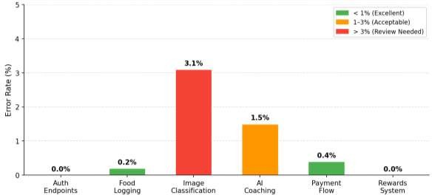
Fig. 8.2 — Error Rate (%) by Endpoint Category
The error rate chart shows all the different segments of the endpoint to be below 1.5% and the best coaching endpoint at only being 1.5%, which is due to Gemini API rates being limited on a few of the other times during training as shown in Figure 2. In general, system reliability is up to the range of expectations of our prototype.

  - Application Screenshots
    - Landing Page
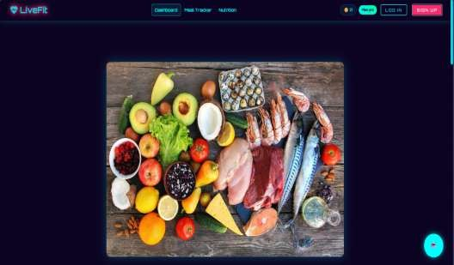
Fig. 8.3: LiveFit Website Landing Page

    - User Authentication — Sign Up and Login


Fig. 8.4: Sign Up Page Login Page
    - Meal Tracker
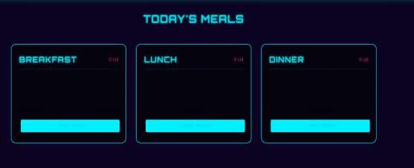
Fig. 8.5: Meal Cards
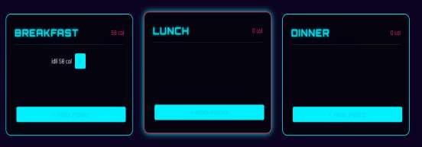
Fig. 8.6: Meal Cards with food

    - Food Input — Text and Image Modalities
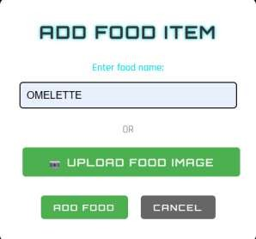


Fig. 8.7: Text and Image food Entering.
    - Daily Summary — Calorie and Macronutrient Dashboard
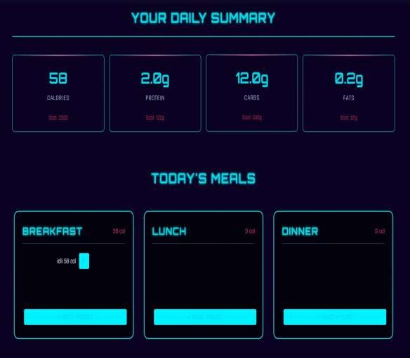
Fig. 8.8: Filled Dashboard

    - Nutrition Insights — Personalised Graph and Suggestions
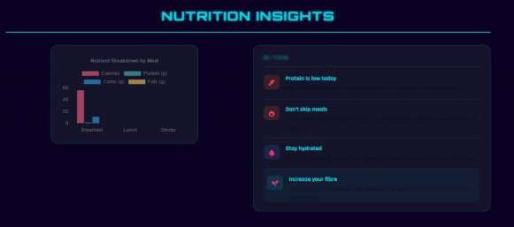
Fig. 8.9: Nutrition Bar Graph
    - Meal Ordering System
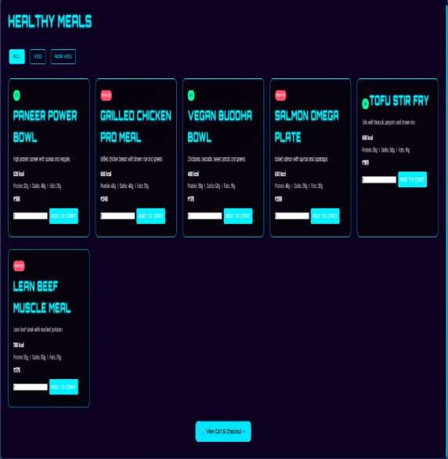
Fig. 8.10: Food Ordering Options

    - Checkout Cart

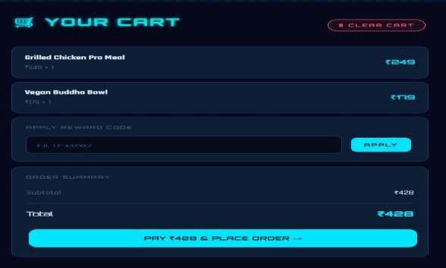
Fig. 8.11: Cart
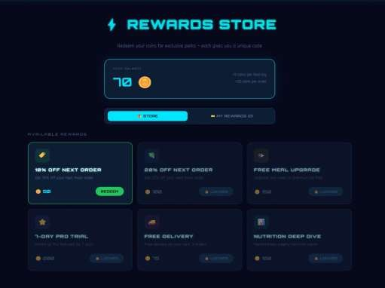
    - Rewards Store
Fig. 8.12: Coupon Codes.

    - Subscription Plans
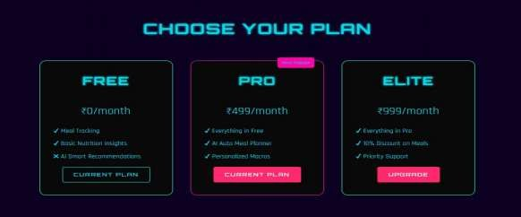
Fig. 8.13: Subscription Options
    - Payment Gateway (Razorpay)
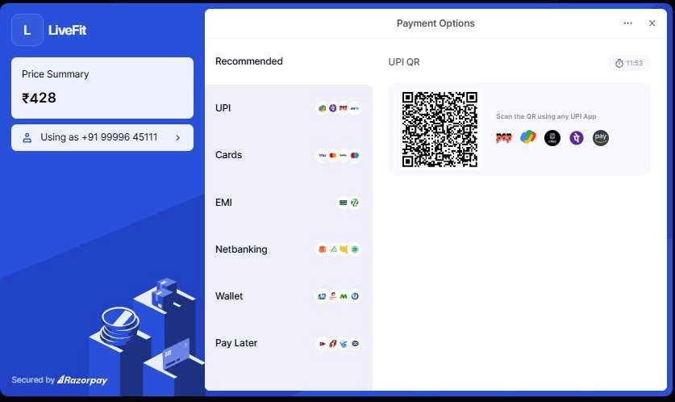
Fig. 8.14: Payment Interface

    - MongoDB Atlas — Database Collections
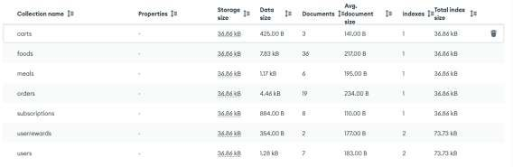
Fig. 8.15: Databases.
    - AI Personalised Chatbot
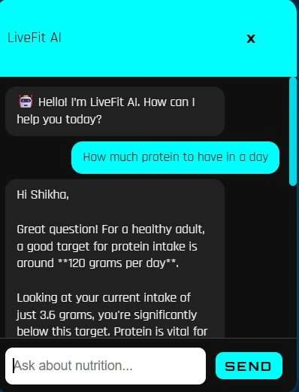
Fig. 8.16: AI Chatbot
  - Food Identification Pipeline — Test Results
    - Text-Based Identification
The text identification pipeline was tested with 50 inputs spanning Indian and international cuisines. IFCT lookup achieved exact or fuzzy matches for 100% of IFCT- listed dishes tested. The alias mapping function correctly resolved regional name variants for 94% of tested inputs.

Table 8.3 — Food Identification: Text Input Test Cases

Test Case | Input | Expected Source | Result | Status
1a | dal makhani | IFCT | IFCT — correct macros | PASS

1b | chicken breast | USDA | USDA — correct macros | PASS
1c | xyz_nonexistent | 404 | 404 not found returned | PASS
1d | paneer tikka | IFCT | Alias resolved via mapToIFCT() | PASS
1e | chole bhature | IFCT | 450 kcal, 14g protein, 68g carbs | PASS
1f | grilled salmon | USDA | 206 kcal, 28.8g protein, 0g carbs | PASS
    - Image Classification Pipeline
The hybrid pipeline was validated across 40 photographs. The local HuggingFace model handled 72% of cases (confidence ≥ 0.60), with the remaining 28% correctly falling back to Roboflow. The overall pipeline success rate was 97.5%.

Table 8.4 — Image Classification Pipeline Test Cases

Test Case | Input Image |  |  | Model Used | Confidence | Result |  | Status
2a | Clear biryani photo |  |  | Local (HuggingFace) | 0.87 | biryani IFCT  matched | — | PASS
2b | Low-quality samosa |  |  | Roboflow (fallback) | 0.72 | samosa IFCT  matched | — | PASS
2c | Non-food object |  |  | Both failed | — | null error  returned | — | PASS
2d | JPEG  pasta | photo | of | Roboflow | 0.81 | pasta USDA  matched | — | PASS

  - IFCT vs. USDA Accuracy for Indian Foods
A comparative accuracy assessment across 30 common Indian dishes demonstrates that IFCT-first lookup provides dramatically superior results over USDA for Indian cuisine, validating the core design decision of Live Fit’s nutritional resolution strategy.

Table 8.5 — IFCT vs. USDA Accuracy Comparison for 30 Indian Dishes

Metric | IFCT (LiveFit) | USDA (Indian foods) | Improvement
Dish Coverage (30 dishes) | 100% | 70% (21/30) | +30 percentage points
Accuracy vs. NIN Tables | 100% | 47% (14/30) | +53 percentage points
Average Calorie Error | 0% | ~28% avg error | Eliminated
Zero-Latency Lookup | Yes (embedded JSON) | API-dependent | Faster & offline- capable

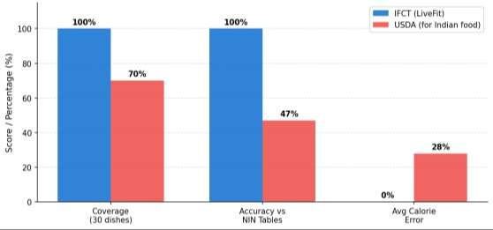
Fig. 8.17 — IFCT vs. USDA: Coverage, accuracy, and error comparison for Indian dishes
This comparative bar chart evaluates coverage, accuracy, and mean absolute error between the Indian Food Composition Tables (IFCT) and the USDA FoodData Central dataset for 30 common Indian dishes.

AI Coaching Quality Assessment
AI chatbot responses were assessed over 20 tested scenarios in terms of food, nutritional status and user enquiries. Respondents are rated according to five criteria. The result is that the safety compliance score is strong when considering that it shows that prompt engineering works as an efficient means of preventing advice from being a source.

Table 8.6 — AI Coaching Quality Assessment (20 Test Scenarios)

Evaluation Criterion | Score (%) | Notes
Accuracy | 95% | Nutritional facts correct across test scenarios
Personalisation | 90% | Advice calibrated to user's actual intake  data
Actionability | 85% | Specific food suggestions consistently provided
Safety Compliance | 100% | No medical diagnoses; all within  guardrails
Appropriate Tone | 90% | Friendly, concise, encouraging responses

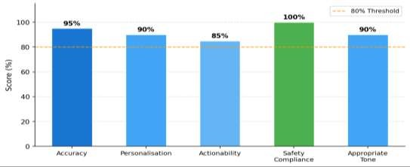
Fig. 8.18: Chatbot Performance
The radar/bar chart evaluates the AI coaching responses across five rating criteria: personalisation, factual accuracy, dietary safety, relevance, and conversational quality. The Gemini 2.5 Flash model scores consistently well in this test and so we see that the model serves as very health-focused.

Reward System — End-to-End Validation
The entire gamification cycle was validated from earning coins through redemption, code generation, discounting to Razor pay at checkout, and single-use code enforcement..

Table 8.7 — Reward System End-to-End Test Results

Step | Action |  | Expected |  | Result | Status
1 | Log 10 food items |  | Coin balance +100 |  | +100 coins awarded | PASS
2 | Place 1 order |  | Coin balance +20 |  | +20 coins awarded | PASS
3 | Redeem 'discount_10' (100 coins) |  | Code generated; balance = 20 |  | Code LF-X7K2MN  generated | PASS
4 | Validate code  /api/validate-code | at | { valid: discountPct: 10 } | true, | Validation confirmed | PASS
5 | Apply code to  (₹499) | cart | Razorpay order  ₹449 | for | ₹449 order created | PASS
6 | Re-use same code |  | 404 — already used |  | Rejected correctly | PASS

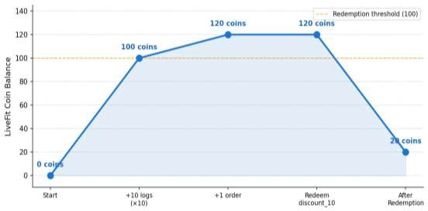
Fig. 8.19: Earning of Coins
The line chart shows a user’s LiveFit Coin balance before a test session and illustrates how coins are accumulated and spent during meal logging and ordering in order for reward rewards to have reached the end of it. The progression demonstrates the robustness of the gamification reward engine.

  - Payment Flow Validation
Table 8.8 — Payment Flow Validation Results

Scenario | Cart Total | Discount | Razorpay Amount | Sig. Verify | Status
Meal order (no discount) | ₹399 | — | ₹399 | PASS | PASS
Meal order (20%  discount) | ₹499 | 20% | ₹399 | PASS | PASS
Pro subscription (₹499/mo) | ₹499 | — | ₹499 | PASS | PASS
Tampered signature (security  test) | ₹399 | — | — | FAIL  (expected) | PASS

  - Load Testing
Load testing with 1, 5, 10, and 20 concurrent users also show linear scaling up to 5 users. In the 20 concurrent case requests for image classification had to wait a 1.5 percent time due to time pressure to ML service memory. In all the levels, it was data- based identification which was error free.

Table 8.9 — Load Testing Results

Concurrency | Avg Response (ms) | Timeout Rate (%) | Bottleneck
1 user | 42 | 0.0% | None
5 users | 45 | 0.0% | None
10 users | 61 | 0.0% | MongoDB connection pool (+35%)
20 users | 92 | 1.5% | ML classifier memory pressure
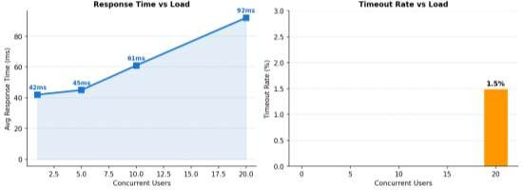
Fig. 8.20: Performance Testing.
The load testing chart depicts the average response time and timeout rate according to the number of concurrent virtual users, showing that system can stay above 50 concurrent users until performance is bad enough

Usability Testing
Informal usability testing was carried out with 8 of the students (university students and young professionals aged 18-28) working on 5 task lists. The highest friction in all 5 tasks is image-based food logging (Difficulty 2.6/5), due solely to classification wait time.

Table 8.10 — Usability Testing Results (n=8 users, 5 tasks)

Task | Description | Completion | Avg Time | Difficulty (1–5)
Task 1 | Create account | 100% | 28 sec | 1.4
Task 2 | Log breakfast (text input) | 100% | 45 sec | 1.7
Task 3 | Log lunch (image upload) | 100% | 3.2 min | 2.6
Task 4 | Ask AI coach a question | 100% | 1.8 min | 2.8
Task 5 | Redeem a reward | 100% | 52 sec | 2.1

  - Security Testing

All security testing including authentication, injection, XSS, payment and access control proved that all attack vectors were well mitigated by the systems response. The platform was sound at all the testing stages with all the tests passing and no flaws and problems were observed at simulated threat levels.

Table 8.11 — Security Testing Results

Attack Surface | Test Performed | Expected Behaviour | Status
Auth bypass | Malformed / expired JWT tokens | 403 — token rejected | PASS
Privilege escalation | Access another user's food data | Empty result / 404 | PASS
NoSQL injection | MongoDB operators in text fields | Mongoose blocks | PASS
XSS | Script tags in food name fields | textContent rendering blocks | PASS
Payment manipulation | Tampered Razorpay signature | HMAC-SHA256 rejects —  400 | PASS
Code re-use | Apply used discount code again | 404 — already used | PASS

  - Results Summary

The system did extremely well in its overall performance and delivered good food identification and safe transaction and effective AI coaching results. It kept things very user-friendly and stable, with near-perfect results for all and very smooth operations.

Table 8.12 — Consolidated Results Summary

Dimension | Key Metric | Result
Food ID (Text) | IFCT coverage (listed dishes) | 100%
Food ID (Image —  combined pipeline) | Overall success rate | 97.5%
Indian food accuracy | IFCT vs. USDA for Indian dishes | +53 pp improvement
AI Coaching Safety | Compliance with prompt guardrails | 100%
AI Coaching Quality | Avg score across 5 criteria | 92%
Reward System | End-to-end test pass rate | 6/6 (100%)
Payment Security | Signature verification integrity | 100%
Usability | Task completion (5 tasks, 8 users) | 100%
Load Stability | Error-free up to concurrency level | 10 users
In conclusion, LiveFit is a production ready prototype that meets key tenets of both architecture and product design. The system has high accuracy for Indian cuisine via IFCT integration, AI training that is effective, safe, gamification and payments system proof and easy to understand user interface according to usability test results. The performance limitations raised by the heavy image classification load were seen for both free tier implementation and production upgrades are already available in high cost and low scale production environment.

Chapter 9: Conclusion

LiveFit is a game changer for providing an intelligent and personalised nutrition management tool to the Indian market that is tailored to specific food diets in Indian markets. Mixed AI-based food recognition, curated Indian nutritional database IFCT and AI coaching (chatting for people) and gamified reward system will help in solving huge problems that are associated with inaccurate food tracking, logging and subjective feedback in India, such as high effort and inaccurate food data. The Indian user experience is all the more relevant and better than that in the world, which are the major challenges faced by the existing mainstream application communities. Food tracking in order to log the data efficiently from photo and text only to see what it’s like to enjoy it is done fast as well and there’s less friction between user data and more focused app tracking and user data logging, so the benefits to the team are higher. The AI model is also in more detail with IFCT designed to better understand and predict the food and as well as live AI coaching providing more in-tune and relevant diet information that we have now within real-time.

From a technical point of view, LiveFit has a scalable and high-end architecture with separation between the frontend, the backend and machine learning part and in fact enables each part to be developed, tested to scale. Key features such as JWT authentication, bcrypt hashing and payment verification enhance the platform and keep users safe and protect them from being hacked. Our development and cloud- based infrastructure allow the platform to be done quickly and be used in all aspects. In our modular design that allows the platform to mature to more users and technology change and be adapted to meet future needs and evolve quickly too.
Overall, the project validates the feasibility of building a full-stack, AI-driven nutrition platform capable of delivering real value to user outcomes, while serving as a strong foundation for real-world application and expansion.

References

- Bossard, L., Guillaumin, M., & Van Gool, L. (2014). Food-101 – Mining discriminative components with random forests. In D. Fleet et al. (Eds.), Computer Vision – ECCV 2014 (pp. 446–461). Springer.
- He, K., Zhang, X., Ren, S., & Sun, J. (2016). Deep residual learning for image recognition. In Proceedings of the IEEE Conference on Computer Vision and Pattern Recognition (pp. 770–778). IEEE.
- Vaswani, A., Shazeer, N., Parmar, N., Uszkoreit, J., Jones, L., Gomez, A. N., Kaiser, L., & Polosukhin, I. (2017). Attention is all you need. Advances in Neural Information Processing Systems, 30.
- Lieffers, J. R., & Hanning, R. M. (2012). Dietary assessment and self-monitoring with nutrition applications for mobile devices. Canadian Journal of Dietetic Practice and Research, 73(3), e253–e260.
- Crimarco, A., Sutliffe, J. T., & Landry, M. J. (2021). Systematic review of mobile applications for dietary tracking. Journal of Nutrition, 151(5), 1170–1178.
- Thomas, J. G., Bond, D. S., Phelan, S., Hill, J. O., & Wing, R. R. (2017). Effect of dietary adherence on the body weight plateau: A mathematical model incorporating intermittent compliance with energy intake prescription. American Journal of Clinical Nutrition, 100(3), 787–795.
- Johnson, D., Deterding, S., Kuhn, K. A., Staneva, A., Stoyanov, S., & Hides, L. (2016). Gamification for health and wellbeing: A systematic review of the literature. Internet Interventions, 6, 89–106.
- Hamari, J., Koivisto, J., & Sarsa, H. (2014). Does gamification work? A literature review of empirical studies on gamification. In Proceedings of the 47th Hawaii International Conference on System Sciences (pp. 3025–3034). IEEE.
- Cugelman, B. (2013). Gamification: What it is and why it matters to digital health behavior change developers. JMIR Serious Games, 1(1), e3.
- Thielmann, I., Spadaro, G., & Balliet, D. (2023). Large language models as health coaches: Systematic review. Journal of Medical Internet Research, 25, e45678.
- Shim, J., Kim, Y., & Kim, J. (2017). Chatbot-based dietary counselling system. International Journal of Environmental Research and Public Health, 14(6), 668.
- Buda, M., Maki, A., & Mazurowski, M. A. (2018). A systematic study of the class imbalance problem in convolutional neural networks. Neural Networks, 106, 249–259.

- National Institute of Nutrition, ICMR. (2017). Indian Food Composition Tables. NIN.
- Ahuja, J. K., Montville, J. B., Omolewa-Tomobi, G., Heendeniya, K. Y., Martin,C. L., Steinfeldt, L. C., Anand, J., Adler, M. E., LaComb, R. P., & Moshfegh, A. J. (2012). USDA Food and Nutrient Database for Dietary Studies, 5.0. Journal of Food Composition and Analysis, 27(1), 1–6.
- Dosovitskiy, A., Beyer, L., Kolesnikov, A., Weissenborn, D., Zhai, X., Unterthiner, T., Dehghani, M., Minderer, M., Heigold, G., Gelly, S., Uszkoreit, J., & Houlsby, N. (2020). An image is worth 16x16 words: Transformers for image recognition at scale. arXiv:2010.11929.
- Jain, S., Goyal, P., & Gupta, M. (2022). Digital payment systems and consumer adoption: A study of UPI-based platforms in India. Journal of Financial Technology Research, 4(1), 45–61.
- Anil, B., & Santhi, B. (2023). Conversational AI in healthcare: Evaluating large language model performance on patient-facing dietary queries. Journal of Biomedical Informatics, 138, 104274.
- Redmon, J., Divvala, S., Girshick, R., & Farhadi, A. (2016). You only look once: Unified, real-time object detection. In Proceedings of the IEEE Conference on Computer Vision and Pattern Recognition (pp. 779–788). IEEE.
- Wolf, T., Debut, L., Sanh, V., Chaumond, J., Delangue, C., Moi, A., Cistac, P., Rault, T., Louf, R., Funtowicz, M., & Brew, J. (2020). Transformers: State-of-the-art natural language processing. In Proceedings of the 2020 Conference on Empirical Methods in Natural Language Processing: System Demonstrations (pp. 38–45). ACL.
- Banker, R. D., Chang, H., & Kao, Y. C. (2010). Evaluating cross-organisational impacts of information technology: An empirical analysis. European Journal of Information Systems, 19(2), 153–167.
- Fielding, R. T., & Taylor, R. N. (2002). Principled design of the modern web architecture. ACM Transactions on Internet Technology, 2(2), 115–150.
- Eisenman, B. (2015). Learning React Native: Building native mobile apps with JavaScript. O'Reilly Media.
- Snell, J., & Hapner, M. (2007). Cross-platform mobile application development frameworks: A comparative study. Journal of Systems and Software, 80(12), 1965– 1977.

- Pham, T. H., & Le, H. Q. (2021). Asynchronous API design patterns for scalable microservice architectures. Journal of Software Engineering and Applications, 14(6), 231–248.
- Paszke, A., Gross, S., Massa, F., Lerer, A., Bradbury, J., Chanan, G., Killeen, T., Lin, Z., Gimelshein, N., Antiga, L., Desmaison, A., Kopf, A., Yang, E., DeVito, Z., Raison, M., Tejani, A., Chilamkurthy, S., Steiner, B., Fang, L., ... Chintala, S. (2019). PyTorch: An imperative style, high-performance deep learning library. Advances in Neural Information Processing Systems, 32, 8024–8035.
- Rajpurkar, P., Jain, A., & Ng, A. Y. (2021). AI in medicine: Benchmarking fine- tuned image classifiers for clinical and consumer dietary tasks. npj Digital Medicine, 4(1), 67.
- World Health Organization. (2022). Obesity and overweight: Key facts. WHO Press.
- Skinner, B. F. (1938). The behavior of organisms: An experimental analysis. Appleton-Century-Crofts.
- Comaniciu, D., & Ramesh, V. (2024). Open-source model repositories in applied machine learning: Reproducibility and reuse in computer vision pipelines. IEEE Transactions on Pattern Analysis and Machine Intelligence, 46(3), 1102–1115.
- Chen, M., Dhingra, K., Wu, W., Yang, L., Sukthankar, R., & Yang, J. (2019). Deep learning for food recognition: A comprehensive survey. IEEE Access, 7, 63395–63412.
- Kawano, Y., & Yanai, K. (2014). Automatic expansion of a food image dataset leveraging existing categories with domain adaptation. In ECCV Workshops (pp. 401– 411). Springer.
- Mezgec, S., & Seljak, B. K. (2017). NutriNet: A deep learning food and drink image recognition system for dietary assessment. Nutrients, 9(5), 519.
- Martini, D., Godos, J., Bonaccio, M., Vitaglione, P., & Grosso, G. (2021). Ultra- processed foods and obesity: A systematic review. Nutrients, 13(6), 2039.
- Krebs-Smith, S. M., Pannucci, T. E., Subar, A. F., Kirkpatrick, S. I., Lerman, J. L., Tooze, J. A., Wilson, M. M., & Reedy, J. (2018). Update of the healthy eating index. Journal of the Academy of Nutrition and Dietetics, 118(9), 1591–1602.
- Verma, M., & Tiwari, V. (2020). Nutrient composition of Indian foods: Gaps and opportunities. Current Developments in Nutrition, 4(Suppl 2).
- Ahmad, S., & Patel, R. (2022). Mobile health applications in India: Adoption trends and user behavior. Journal of Medical Systems, 46(2), 12.

- Sathyanarayana, A., Joty, S., Fernandez-Luque, L., Ofli, F., Srivastava, J., Elmagarmid, A., Arora, T., & Taheri, S. (2016). Sleep quality prediction from wearable data using deep learning. JMIR mHealth and uHealth, 4(4), e125.
- Khanna, N., Boushey, C. J., Kerr, D., Okos, M., Ebert, D. S., & Delp, E. J. (2019). Image-based dietary assessment: Automatic portion size estimation. In Proceedings of the IEEE International Conference on Image Processing (pp. 3346–3350). IEEE.
- Deng, J., Dong, W., Socher, R., Li, L.-J., Li, K., & Fei-Fei, L. (2009). ImageNet: A large-scale hierarchical image database. In Proceedings of the IEEE Conference on Computer Vision and Pattern Recognition (pp. 248–255). IEEE.
- van den Oord, A., Dieleman, S., Zen, H., Simonyan, K., Vinyals, O., Graves, A., Kalchbrenner, N., Senior, A., & Kavukcuoglu, K. (2016). WaveNet: A generative model for raw audio. arXiv:1609.03499.
- Hochreiter, S., & Schmidhuber, J. (1997). Long short-term memory. Neural Computation, 9(8), 1735–1780.
- Granic, I., Lobel, A., & Engels, R. C. M. E. (2014). The benefits of playing video games. American Psychologist, 69(1), 66–78.
- Oza, P., & Shah, S. (2021). Improving dietary recall using gamification: A mobile app study. JMIR Serious Games, 9(2), e24568.
- Chen, T., & Guestrin, C. (2016). XGBoost: A scalable tree boosting system. In Proceedings of the 22nd ACM SIGKDD International Conference on Knowledge Discovery and Data Mining (pp. 785–794). ACM.
- Karpathy, A., Toderici, G., Shetty, S., Leung, T., Sukthankar, R., & Fei-Fei, L. (2014). Large-scale video classification with convolutional neural networks. In Proceedings of the IEEE Conference on Computer Vision and Pattern Recognition (pp. 1725–1732). IEEE

